**Task on VPC-02**

**1) Create one VPC, with 1 one public subnet and 1 private subnet.**

Create a VPC

- Sign in to the AWS Management Console.

- Navigate to VPC service.

- Click Create VPC.

- Enter:

- Name tag (e.g., MyVPC).

- IPv4 CIDR block (e.g., 192.168.0.0/24).

- IPv6 CIDR block (optional).

- Tenancy (default).

- Click Create VPC.

Create Public and Private Subnets

- Go to Subnets in the VPC dashboard.

- Click Create Subnet.

- Select your VPC.

- Enter:

- Subnet name (e.g., PublicSubnet).

- Availability Zone (choose one).

- IPv4 CIDR block (e.g., 192.168.0.0/26 for public subnet).

- Click Create Subnet.

- Repeat the process for the private subnet:

- Subnet name (e.g., PrivateSubnet).

- IPv4 CIDR block (e.g., 192.168.0.128/26 for private subnet).

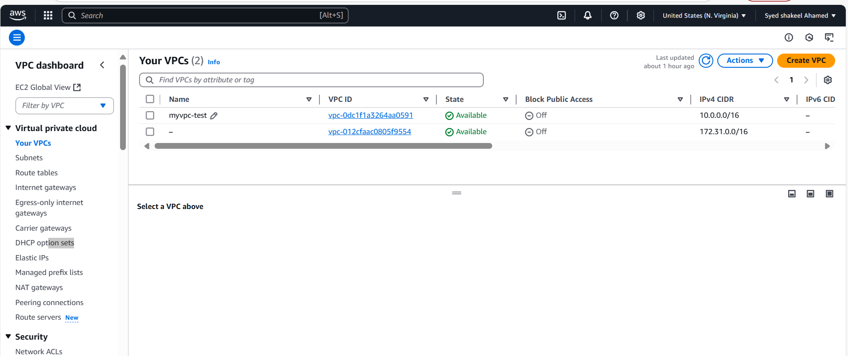

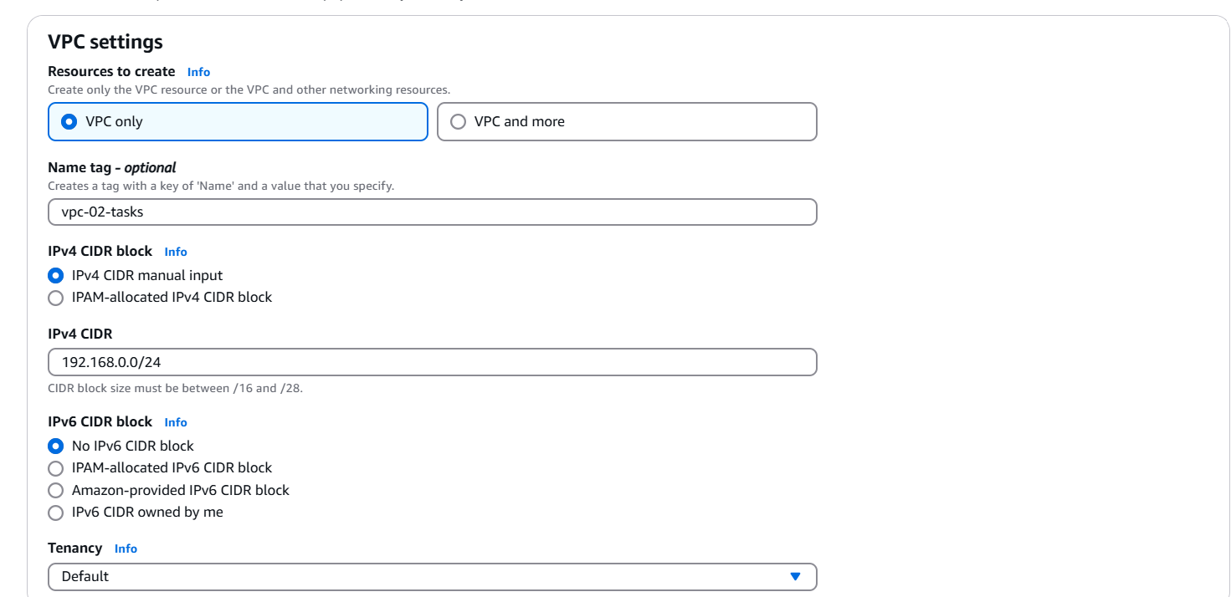

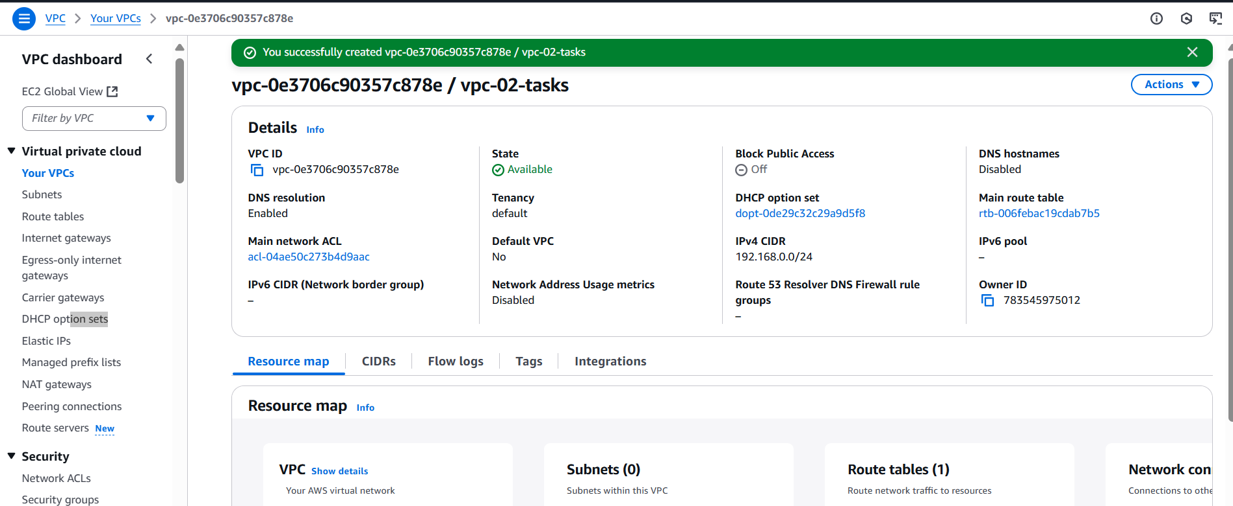

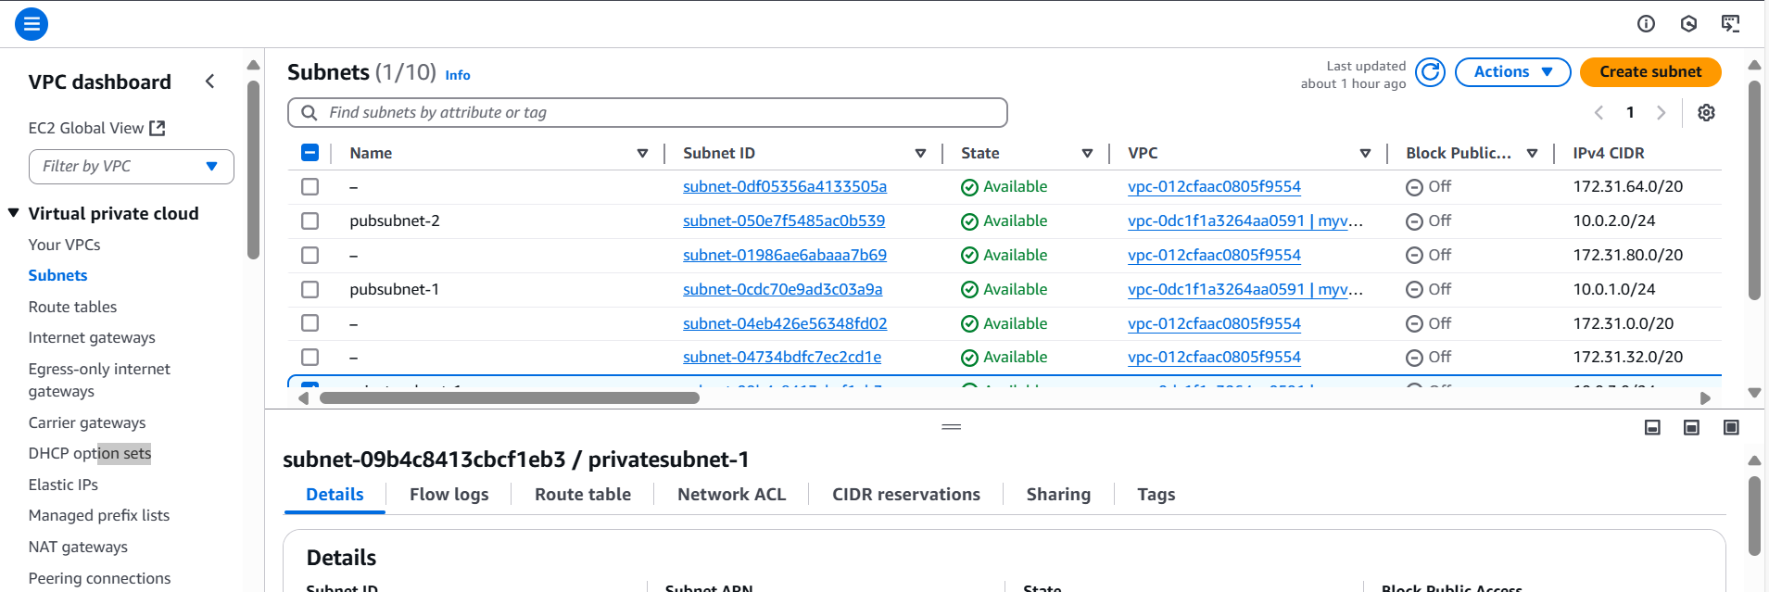

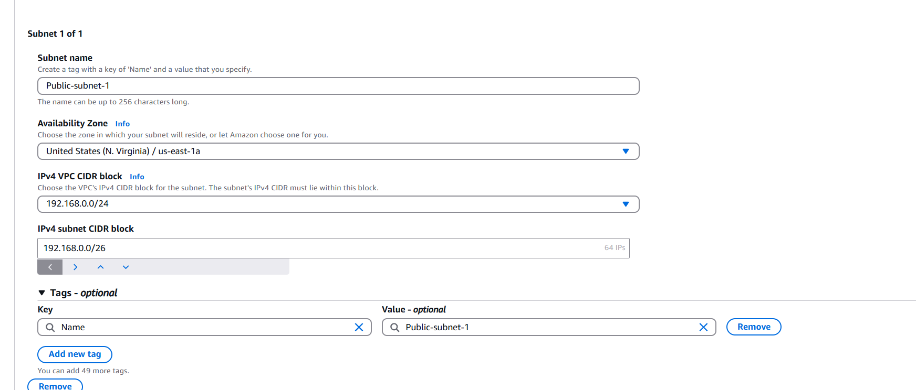

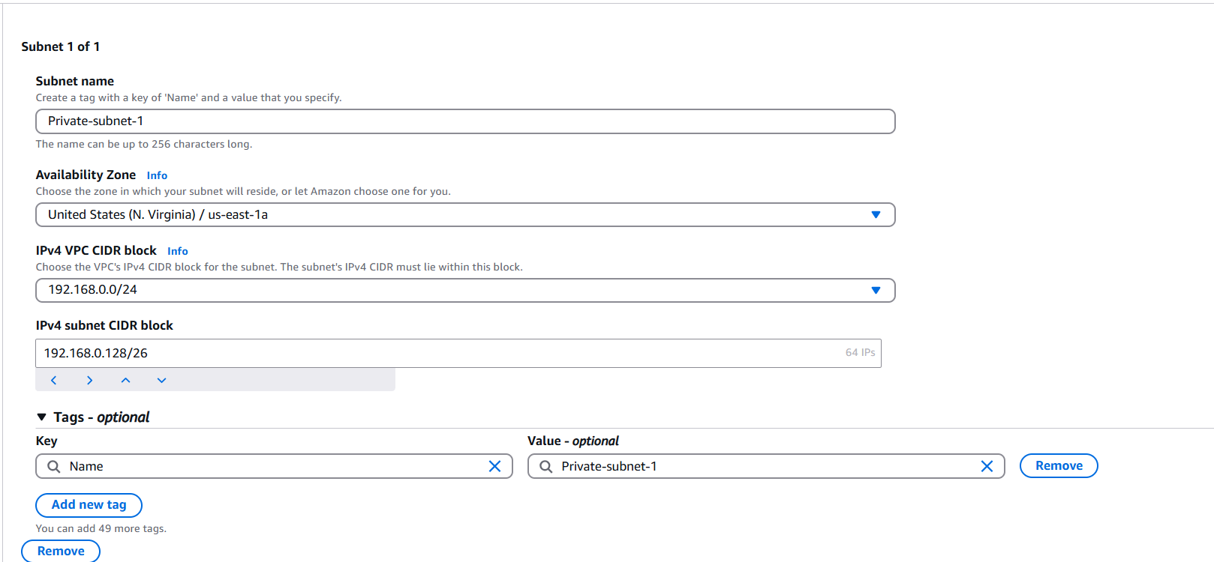

**2) Enable VPC peering for cross region.**

Create VPCs in Both Regions

- Sign in to the AWS Management Console.

- Navigate to VPC service.

- Create a VPC in North Virginia (us-east-1):

- Name: VPC-NVirginia

- CIDR Block: 192.168.0.0/24

- Create a VPC in Ohio (us-east-2):

- Name: VPC-Ohio

- CIDR Block: 172.31.0.0/16

Step 2: Create VPC Peering Connection

- Go to VPC Peering Connections in the AWS Console.

- Click Create Peering Connection.

- Enter:

- Name: NVirginia-Ohio-Peering

- Requester VPC: VPC-NVirginia

- Accepter VPC: VPC-Ohio

- Region: Select Another Region (us-east-2).

- Click Create Peering Connection.

- Accept the peering request in Ohio (us-east-2):

- Navigate to VPC Peering Connections in Ohio.

- Select the request and click Accept.

pcx-00abb237ca6d7d4d9

Update Route Tables

- Go to Route Tables in North Virginia (us-east-1).

- Select the route table associated with VPC-NVirginia.

- Add a new route:

- Destination: 172.31.0.0/16

- Target: Select the VPC Peering Connection (NVirginia-Ohio-Peering).

- Repeat the process for Ohio (us-east-2):

- Destination: 192.168.0.0/24

- Target: Select the VPC Peering Connection.

Update Security Groups

- Go to Security Groups in both regions.

- Allow inbound traffic for:

- Protocol: All Traffic or specific ports (SSH - 22, HTTP - 80, etc.).

- Source: 172.31.0.0/16 (for Ohio) and 192.168.0.0/24 (for North Virginia).

Test Connectivity

- Launch EC2 instances in both VPCs.

- Try pinging or SSH between instances using private IPs.

- If connectivity fails, check:

- Route tables.

- Security group rules.

- Peering connection status.

N.virginia-Public Ec2-instance

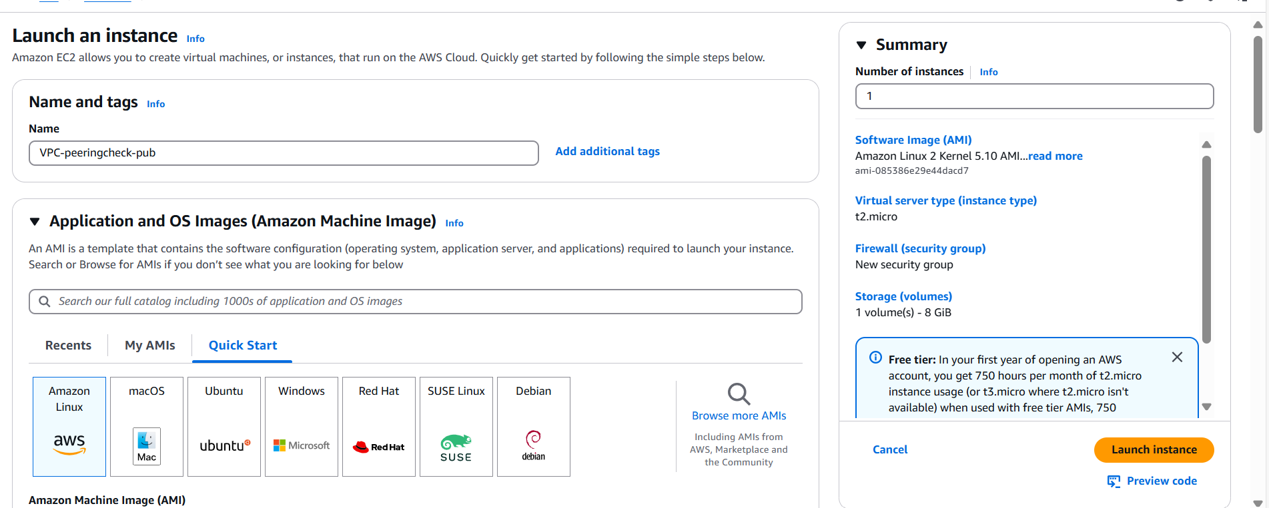

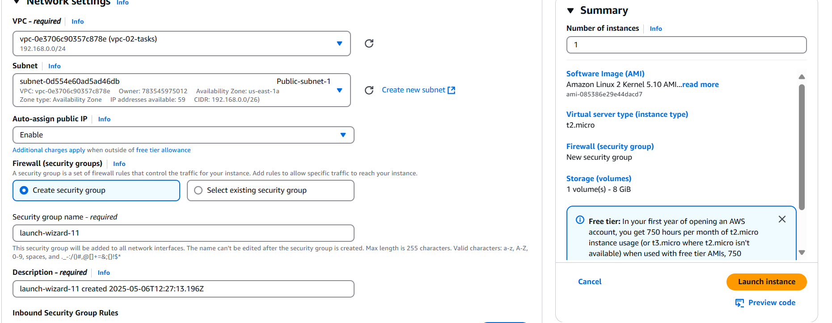

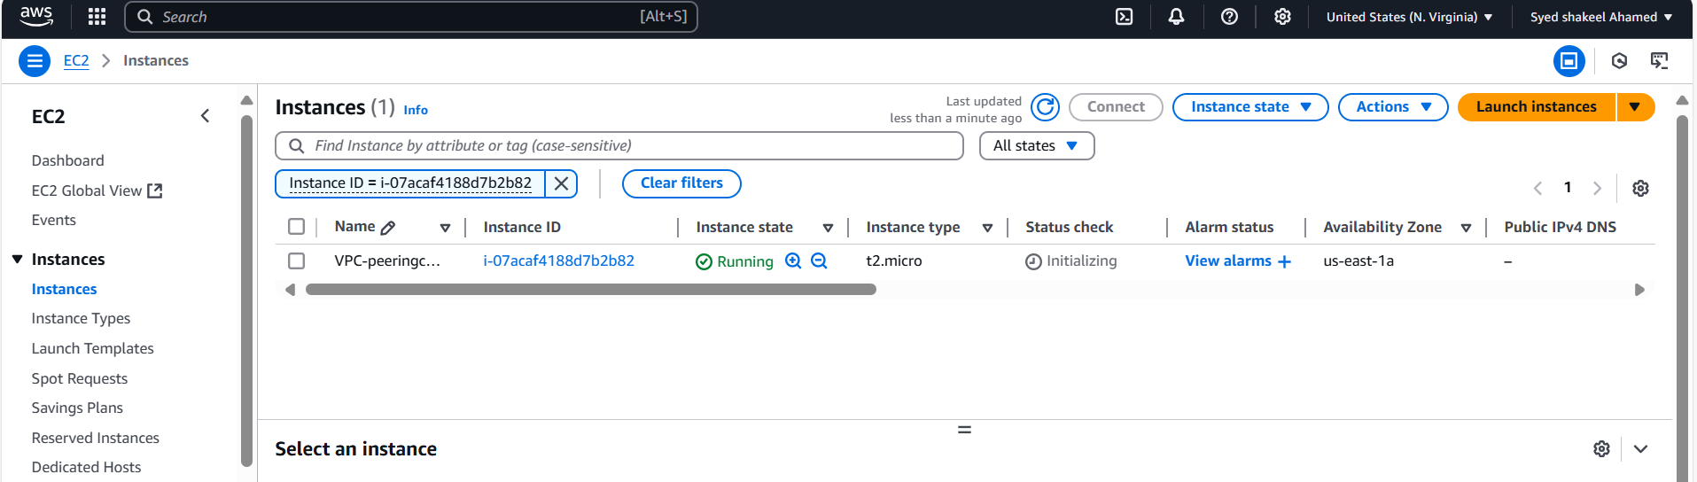

Ohio-Ec2 instance

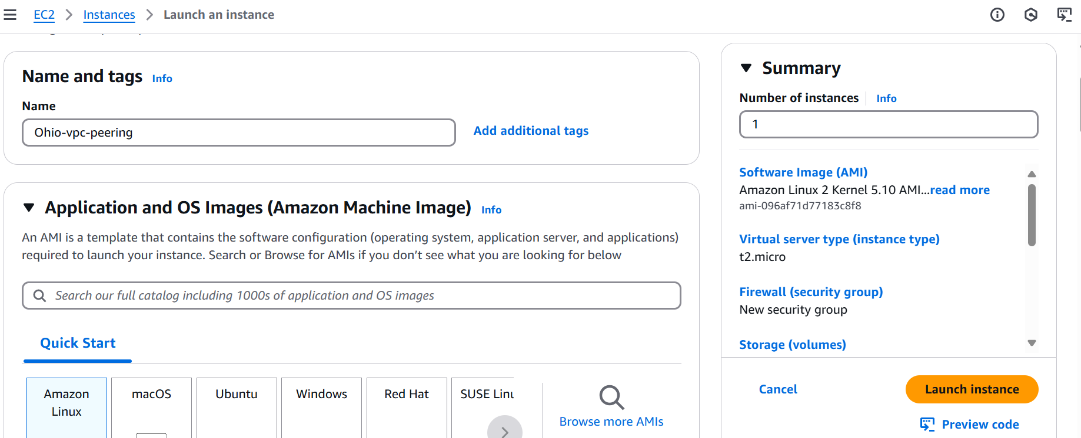

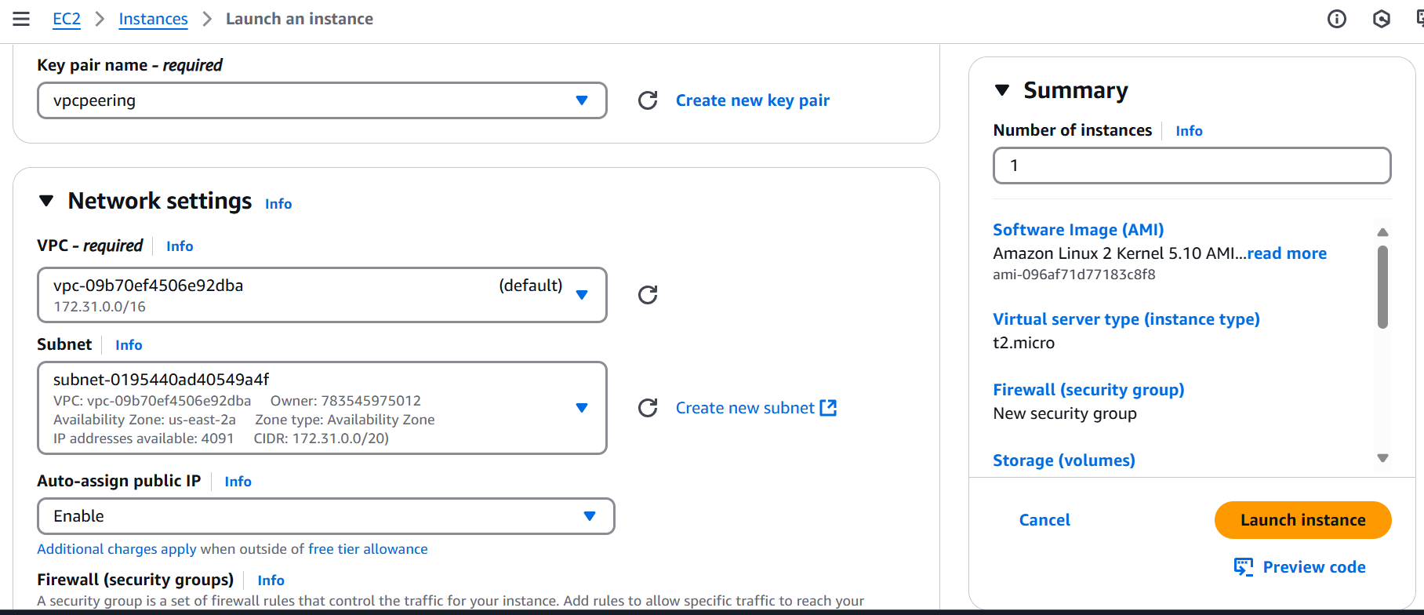

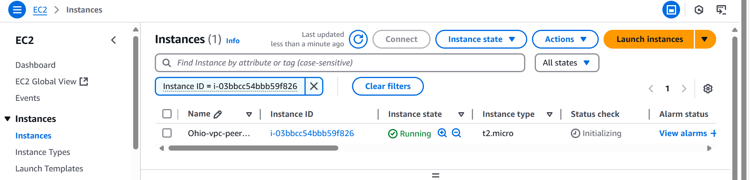

VPC-Peering

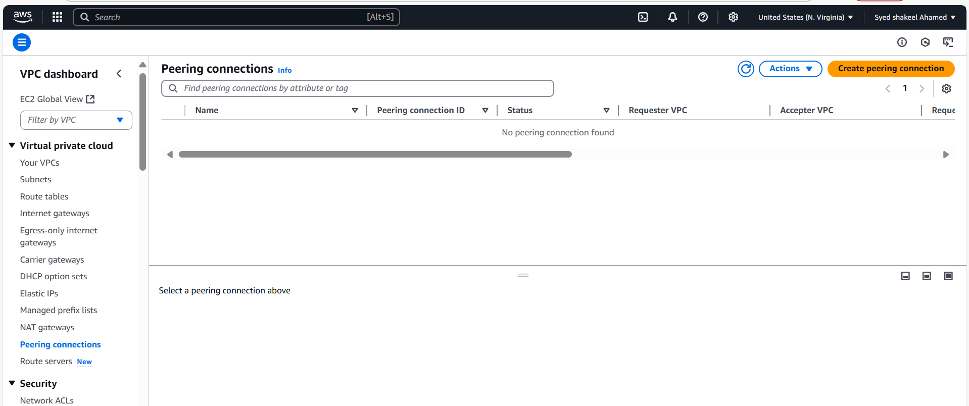

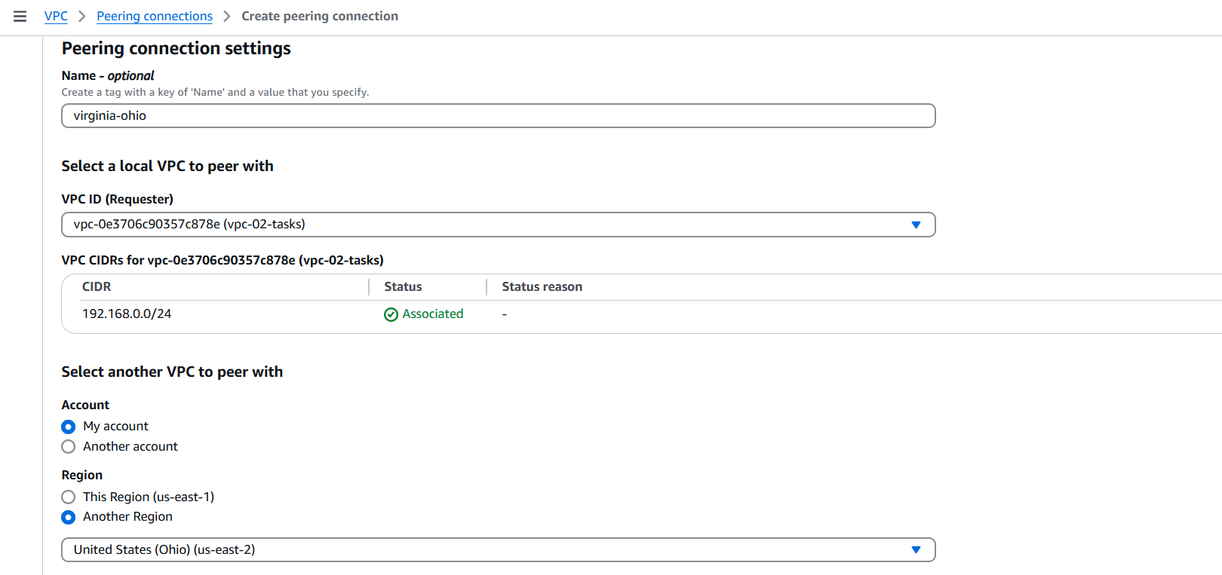

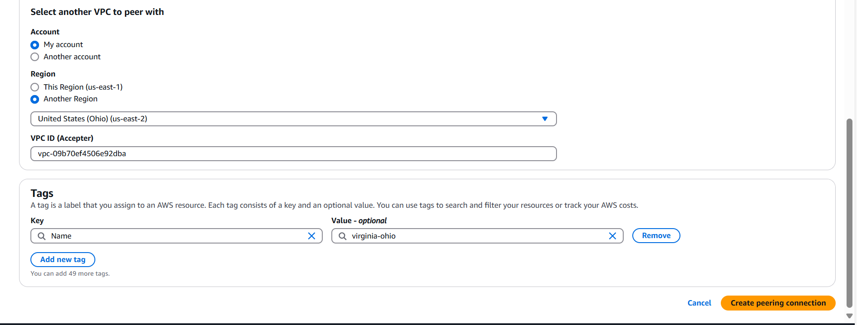

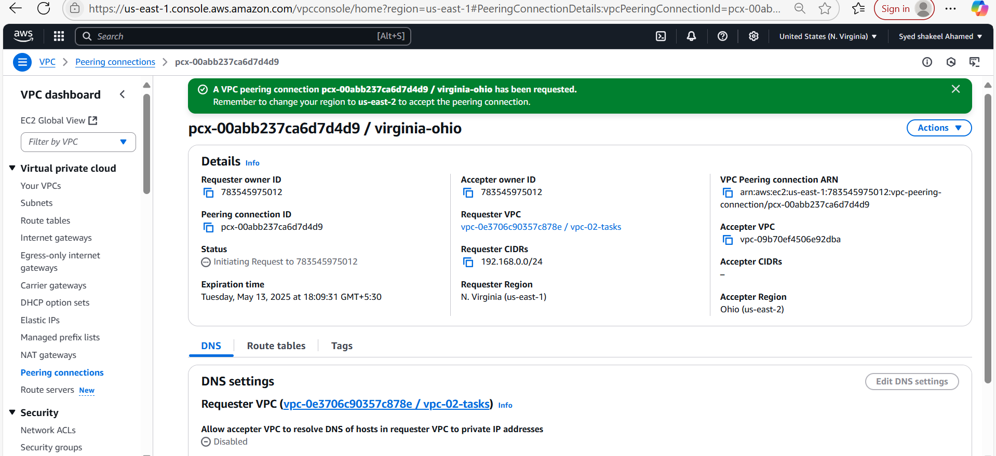

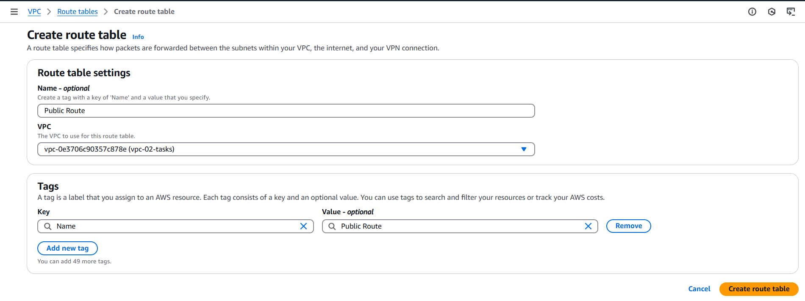

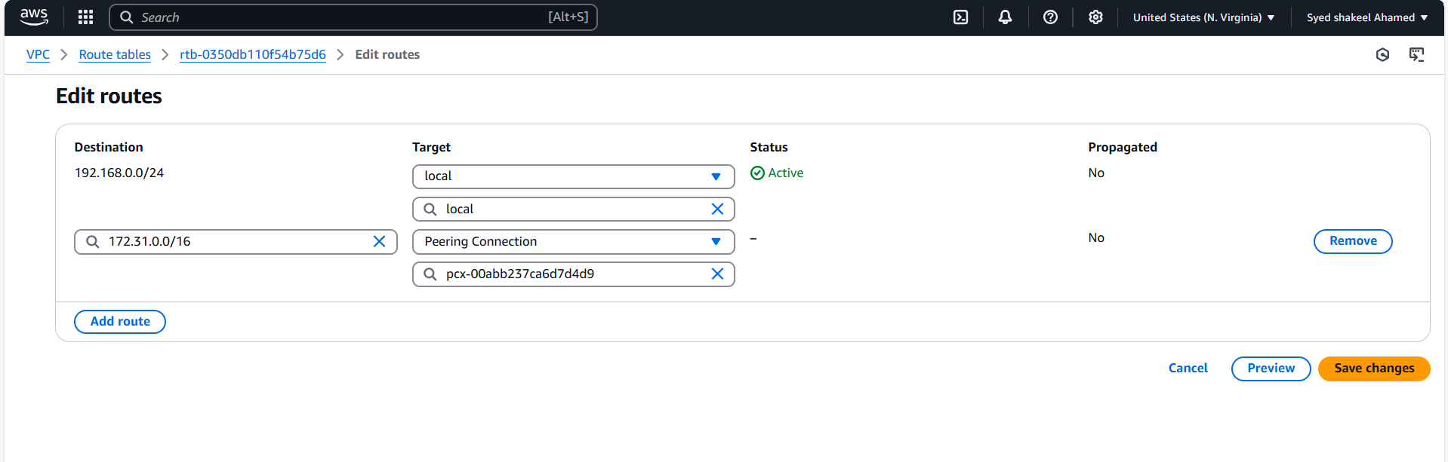

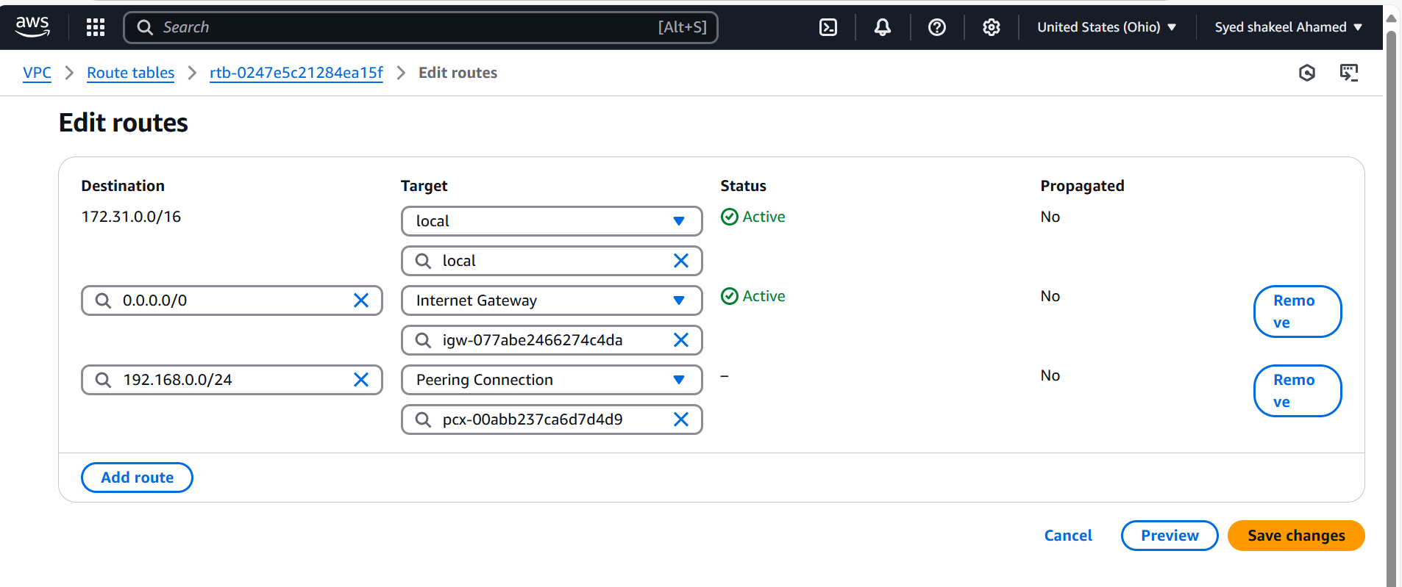

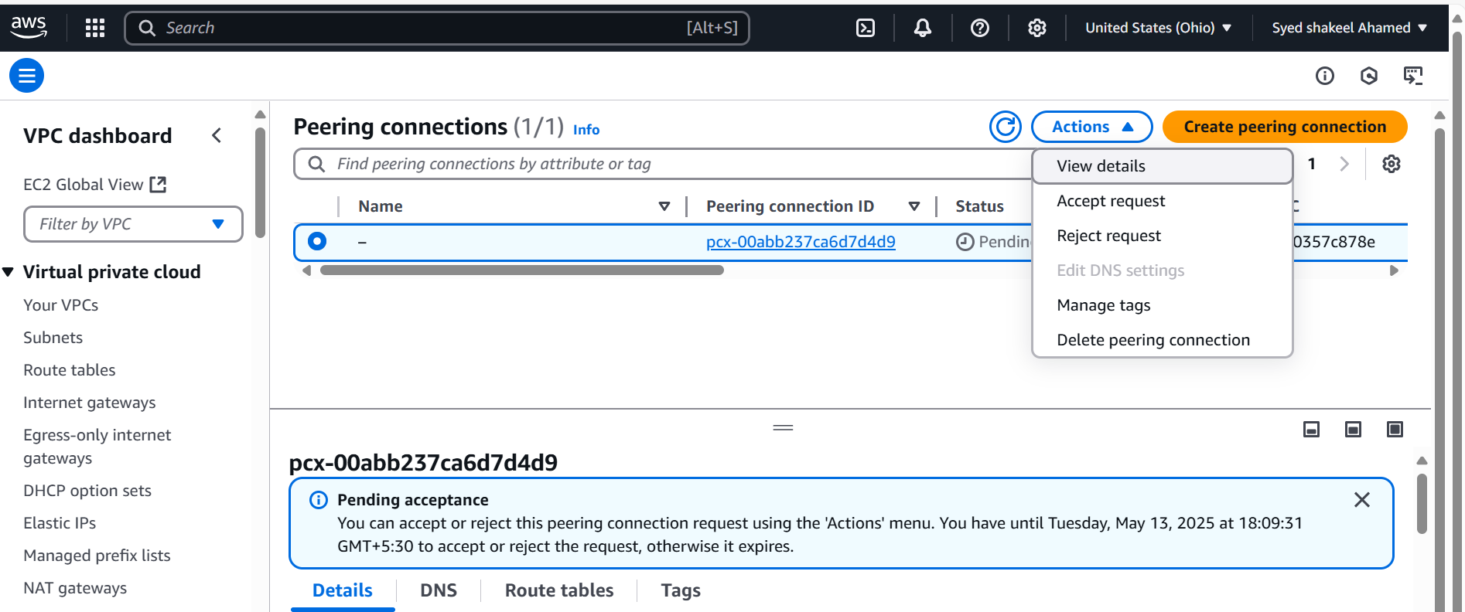

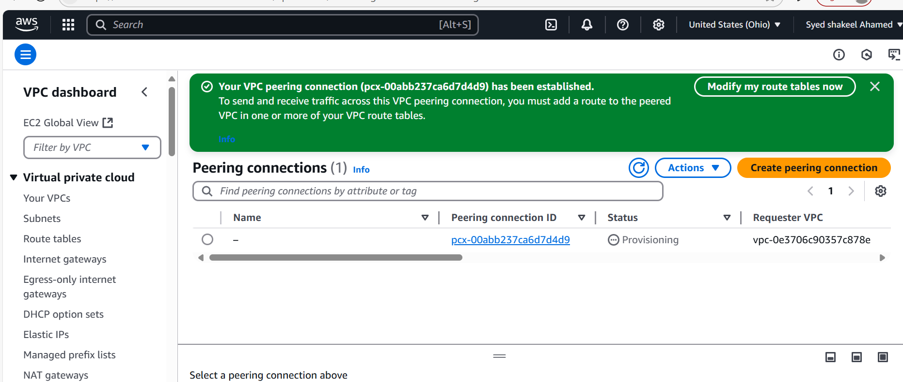

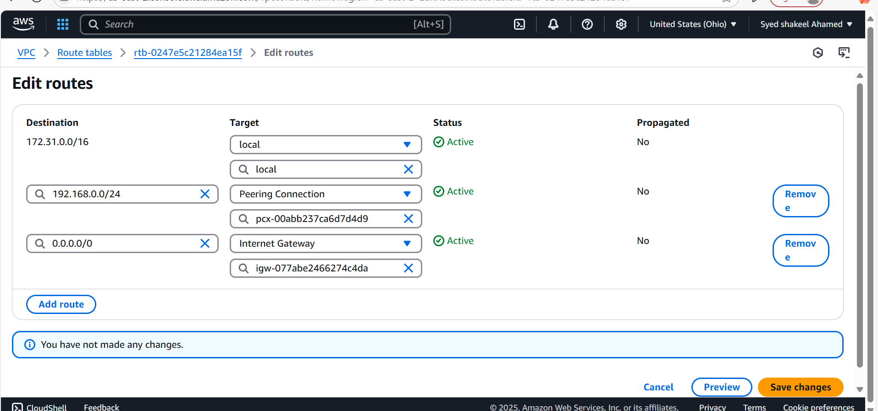

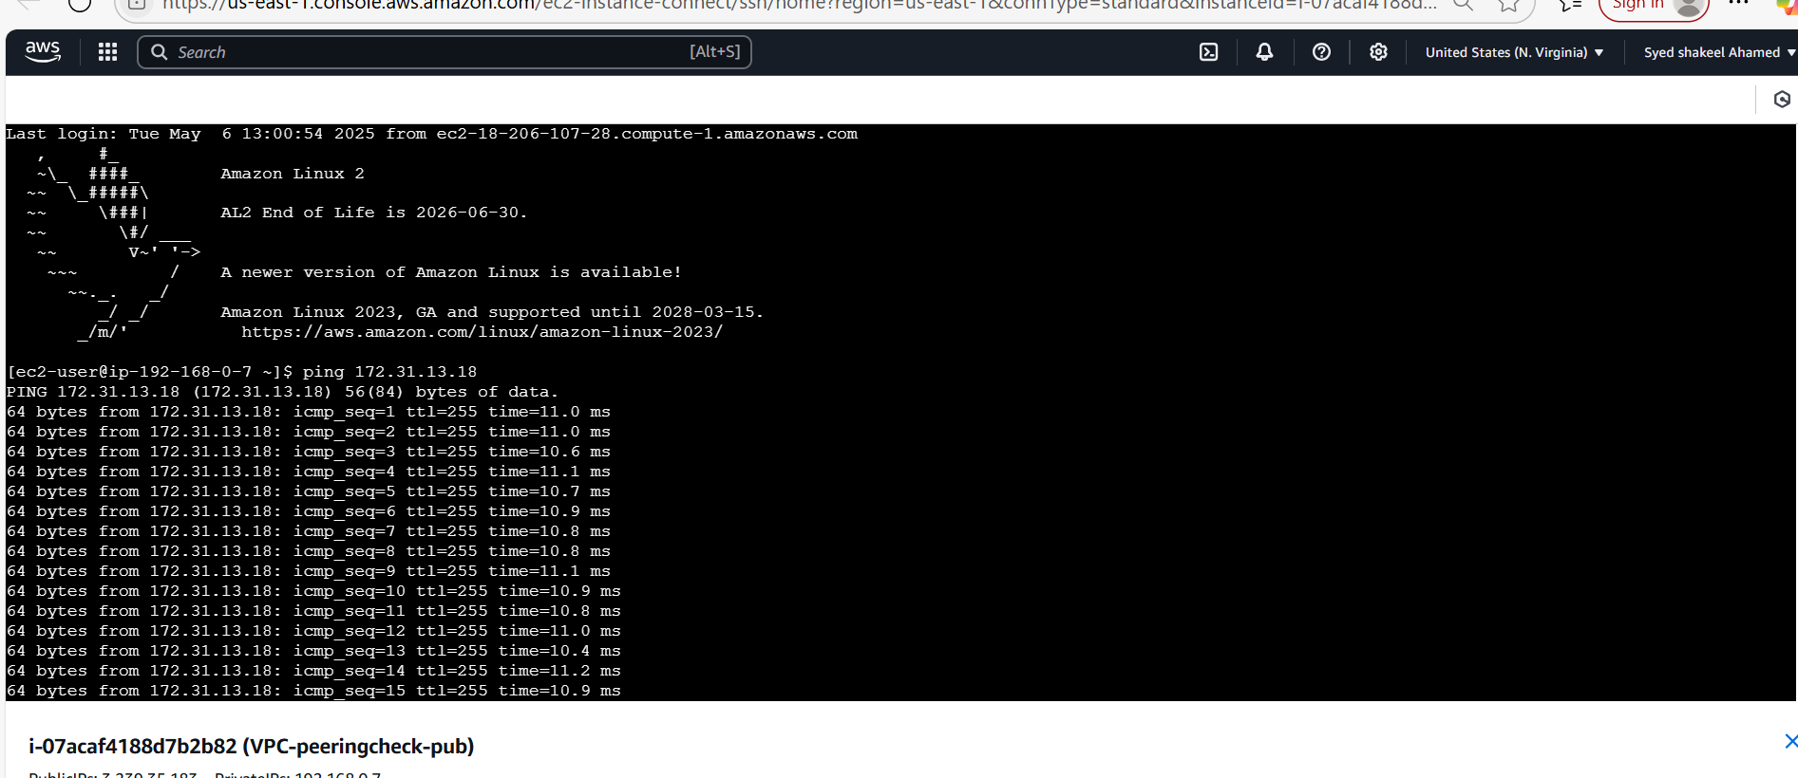

**3) Enable VPC peering for cross account. (You can collaborate with your friend and do this task).**

Navigate to the Amazon console to VPC and create VPC

Name:vpc-peering

IPv4 CIDR 192.168.0.0/24 and create VPC

Now go to Subnet settings

create private subnet with CIDR 192.168.0.0/26

- Create a VPC Peering Connection

- In the AWS Management Console, navigate to VPC Dashboard → Peering Connections → Create Peering Connection.

- Choose Requester VPC (your VPC) and enter the Account ID of the other AWS account.

- Select the Accepter VPC (the VPC in the other account).

- Click Create Peering Connection.

Accept the Peering Request

- The owner of the Accepter VPC must log in and accept the request in the VPC Dashboard.

- Update Route Tables

- Both VPC owners must update their route tables to allow traffic between the VPCs.

- Navigate to Route Tables → Edit Routes → Add Route.

- Set the destination CIDR of the peer VPC and choose the Peering Connection as the target.

Create the internet gateway and attach with it created VPC for peering connection

Now Launch the EC2 private instance with proper network settings with vpc and subnet

Now update the Route table with edit route option and add route with destination and target of other account CIDR

Now Test the connection using CLI

Now connect the ec2 private instance

Now ping private ip of other account EC2 private instance

Successfully enabled vpc peering for cross account with same region

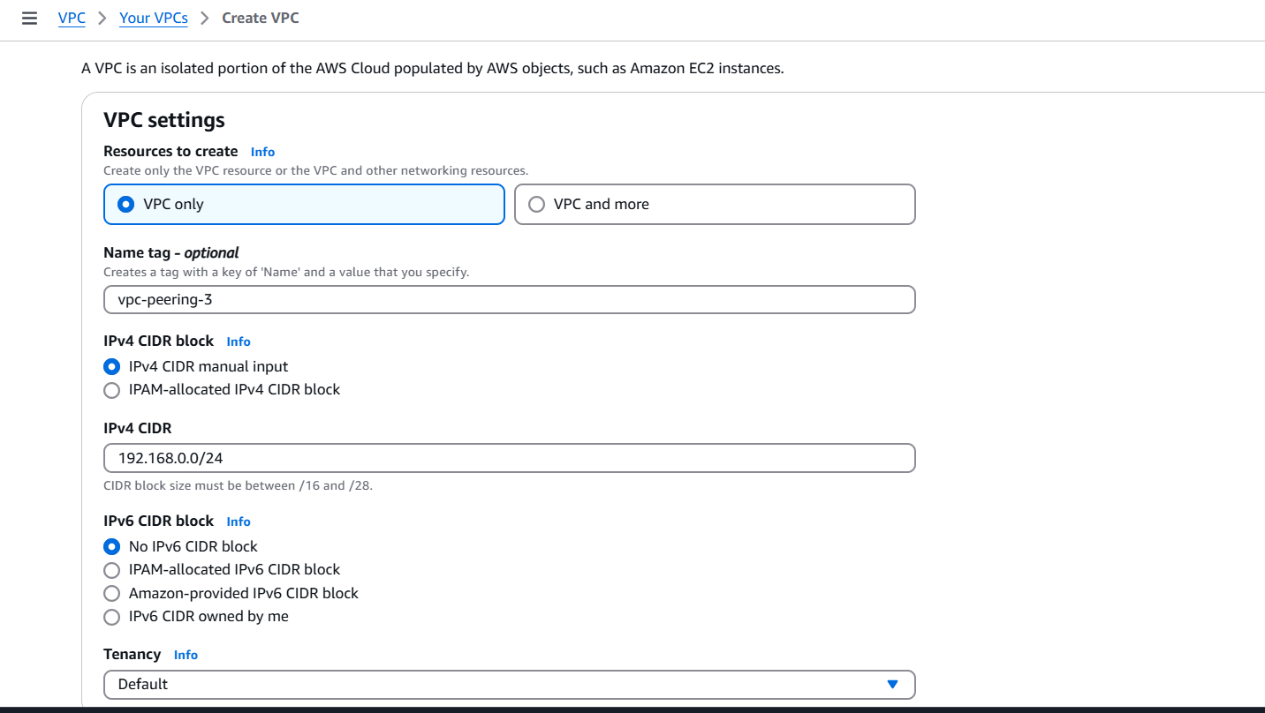

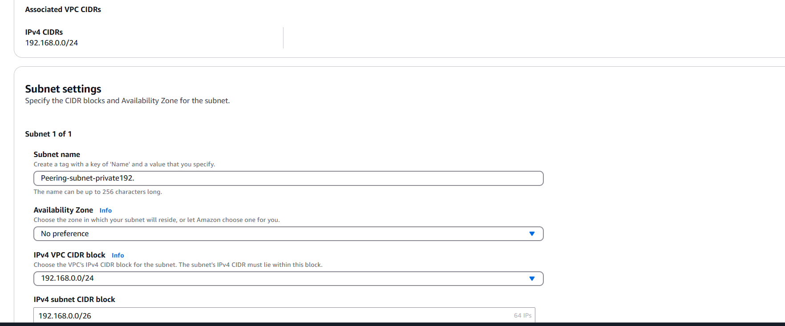

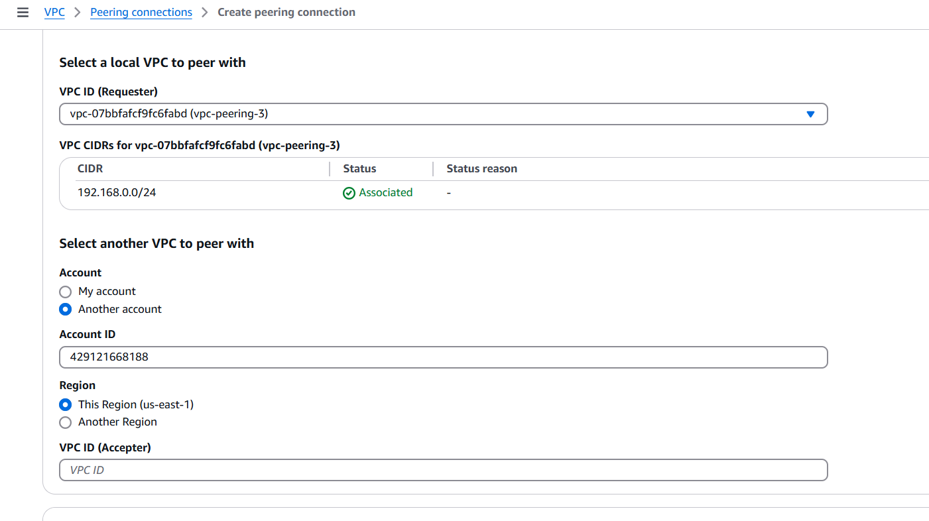

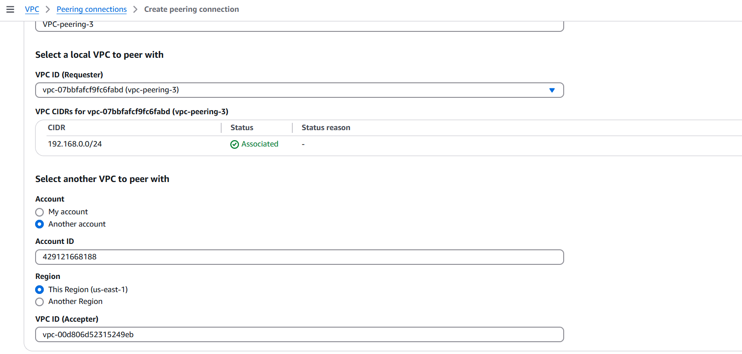

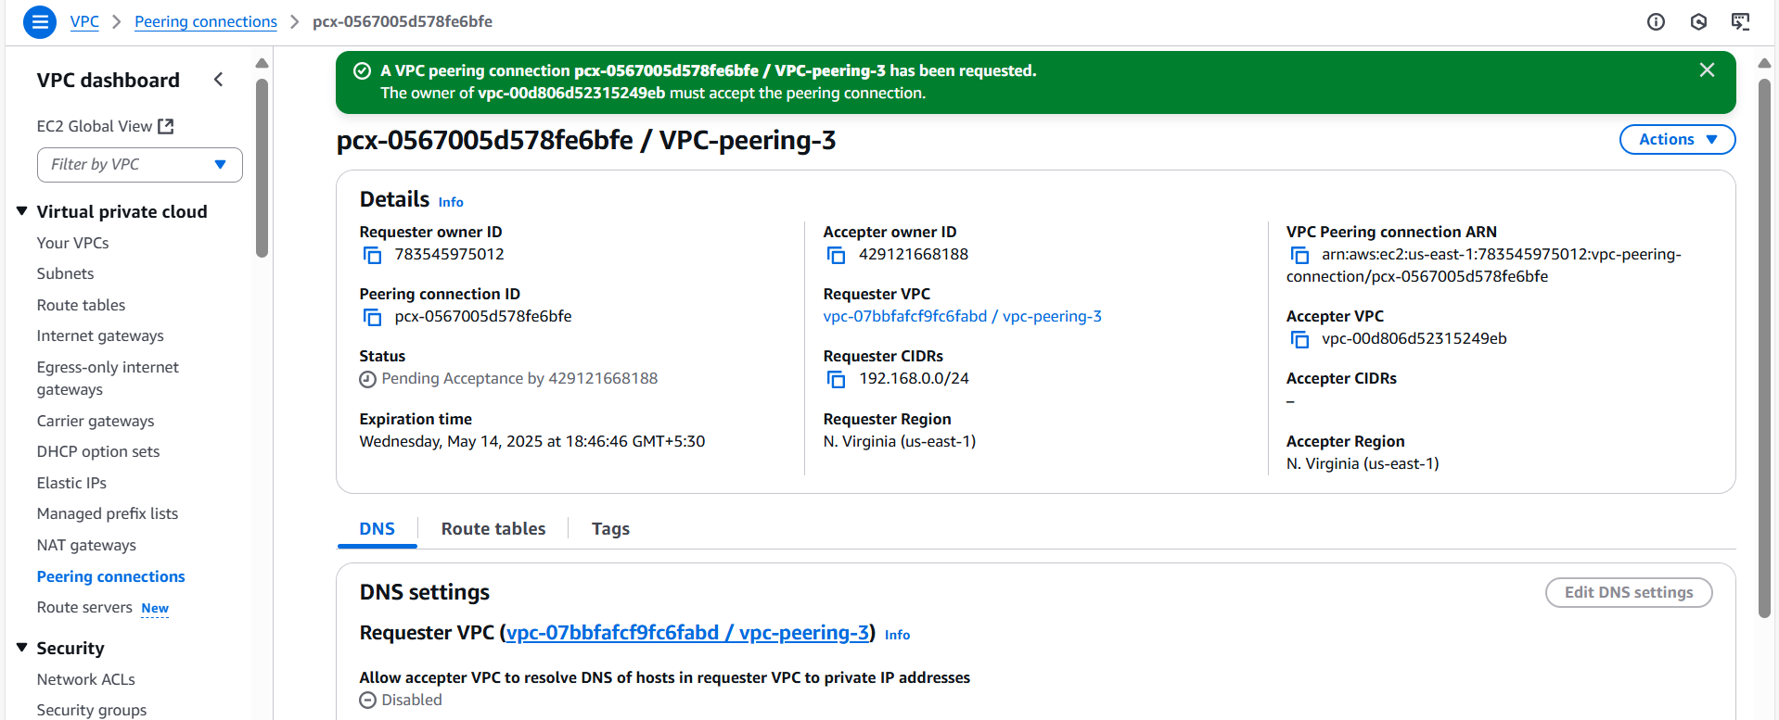

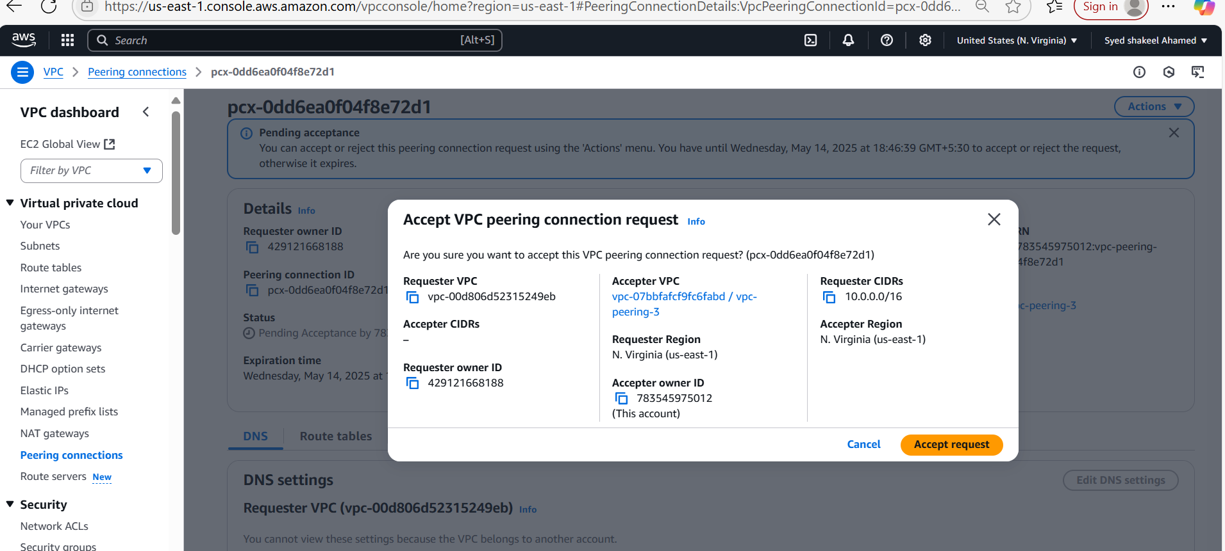

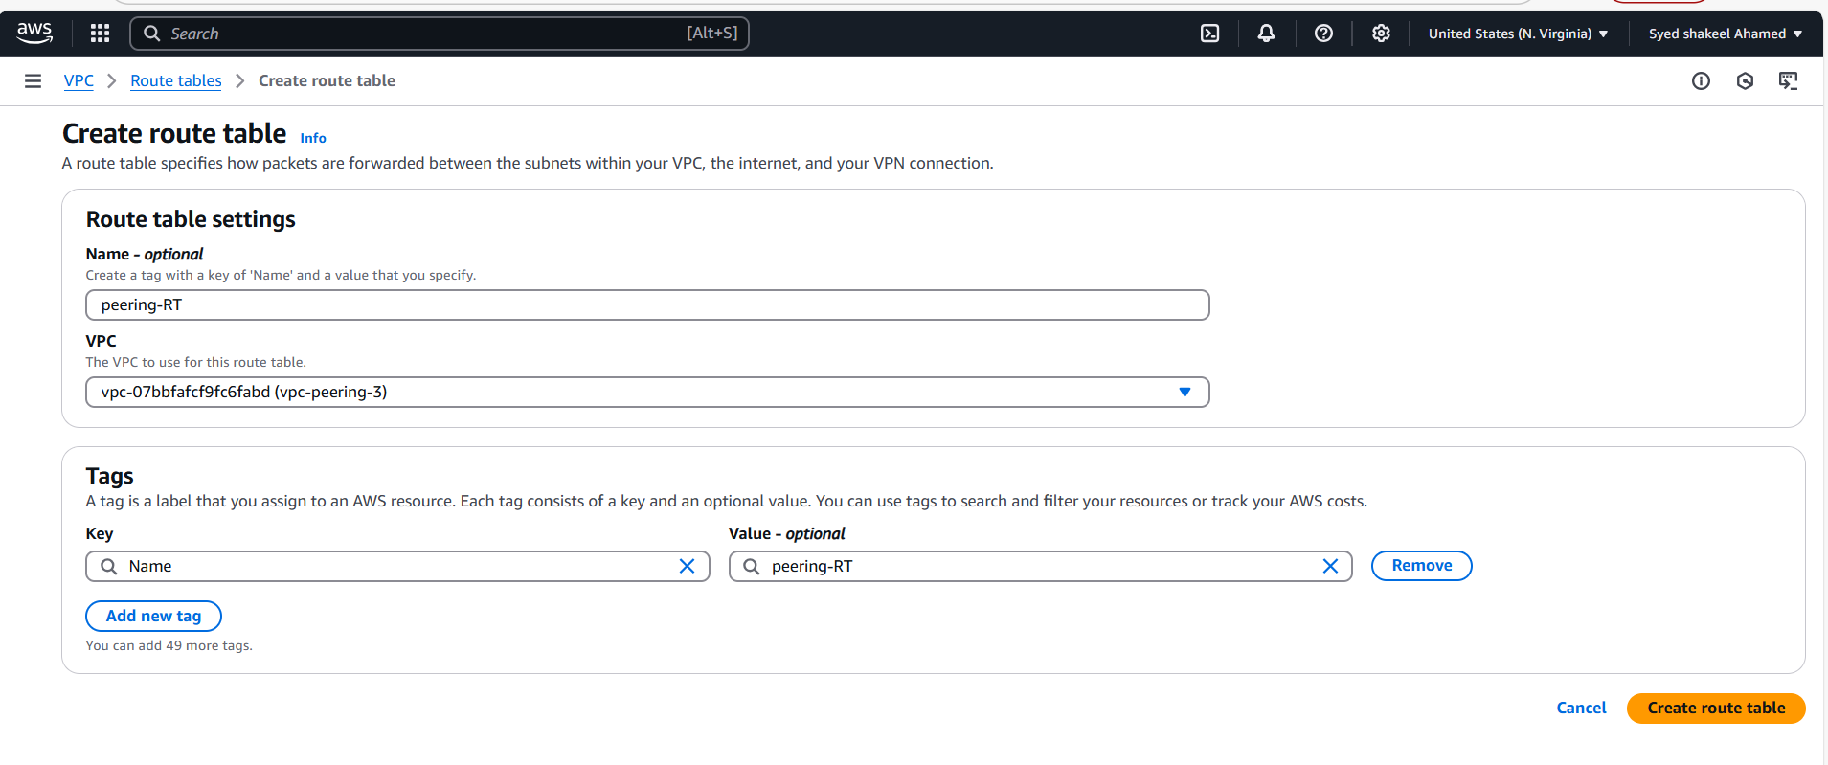

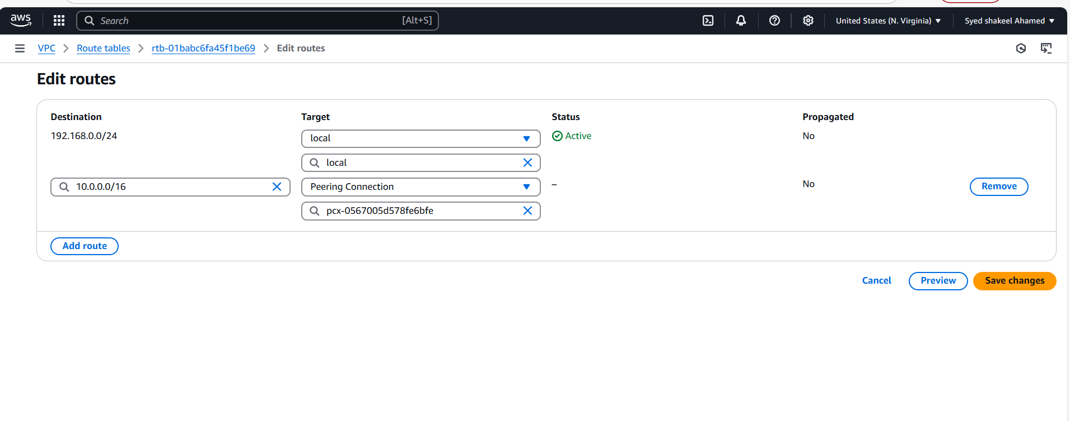

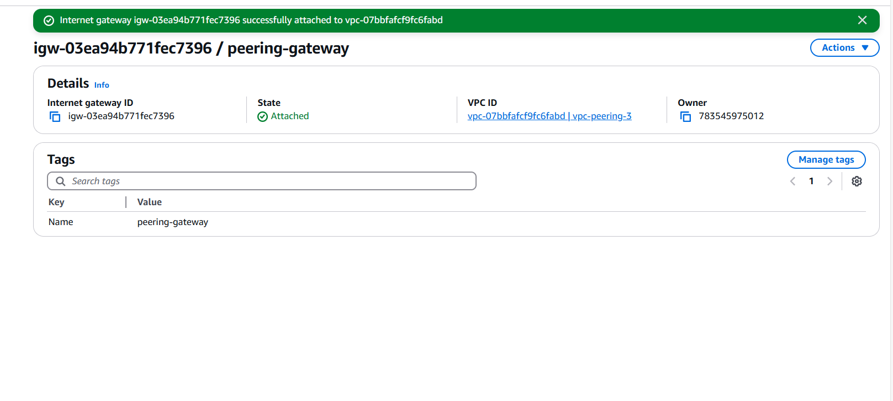

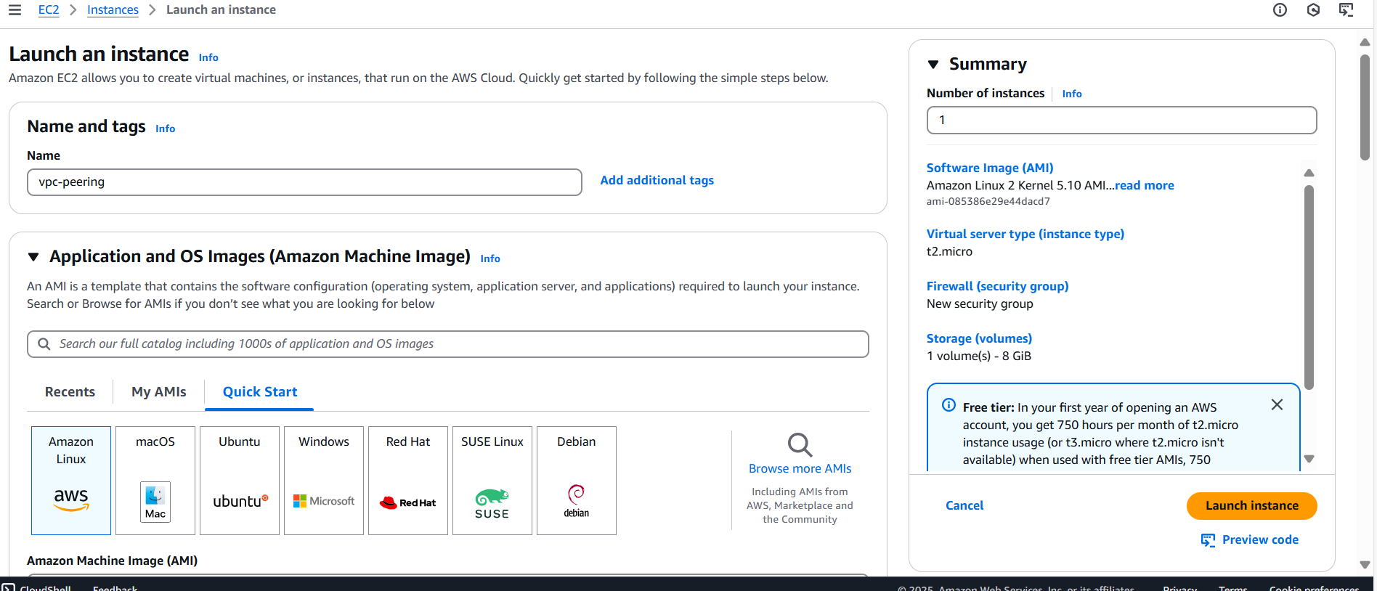

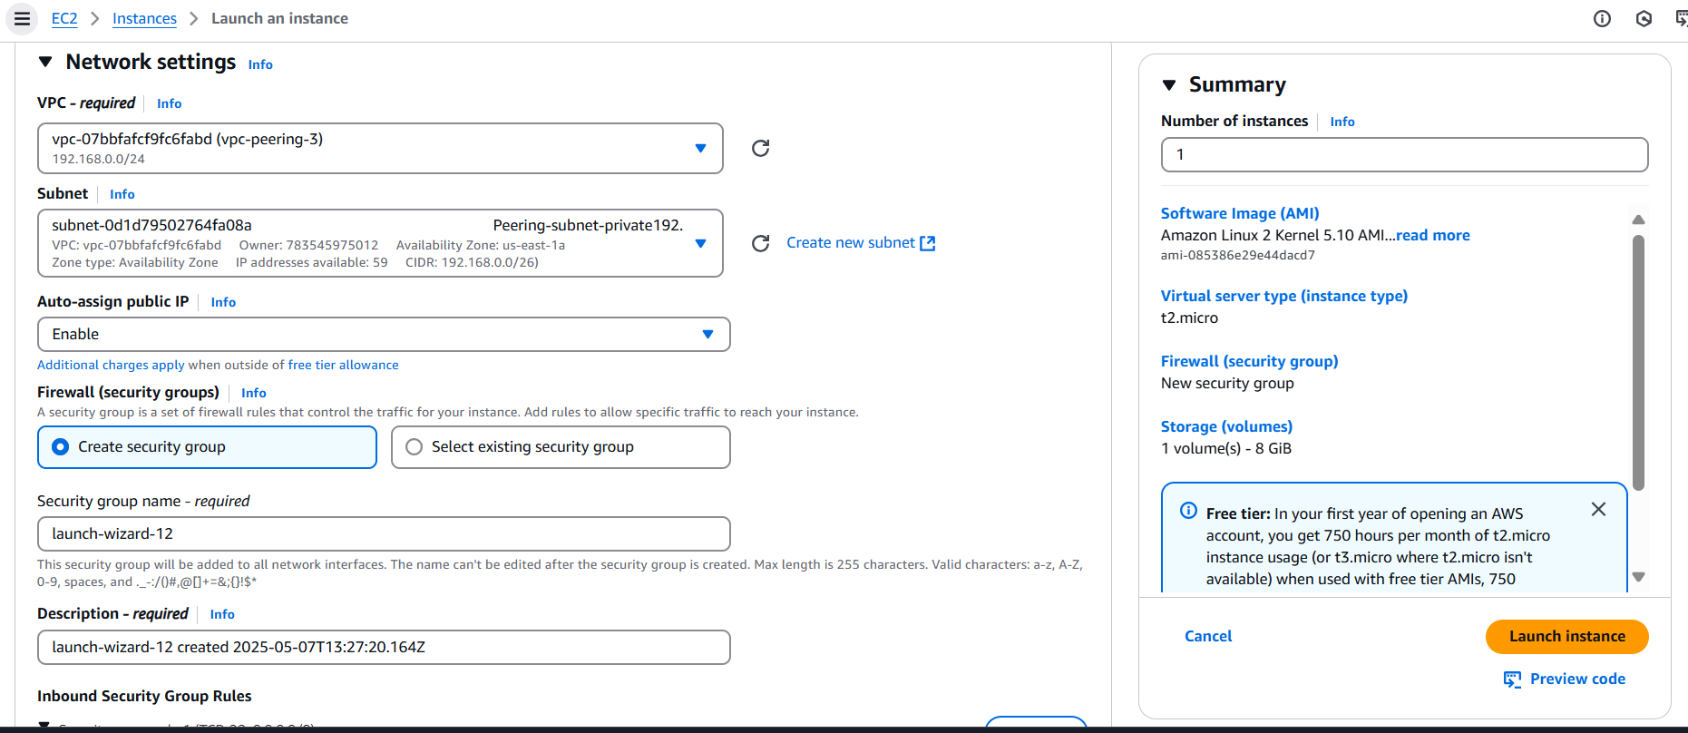

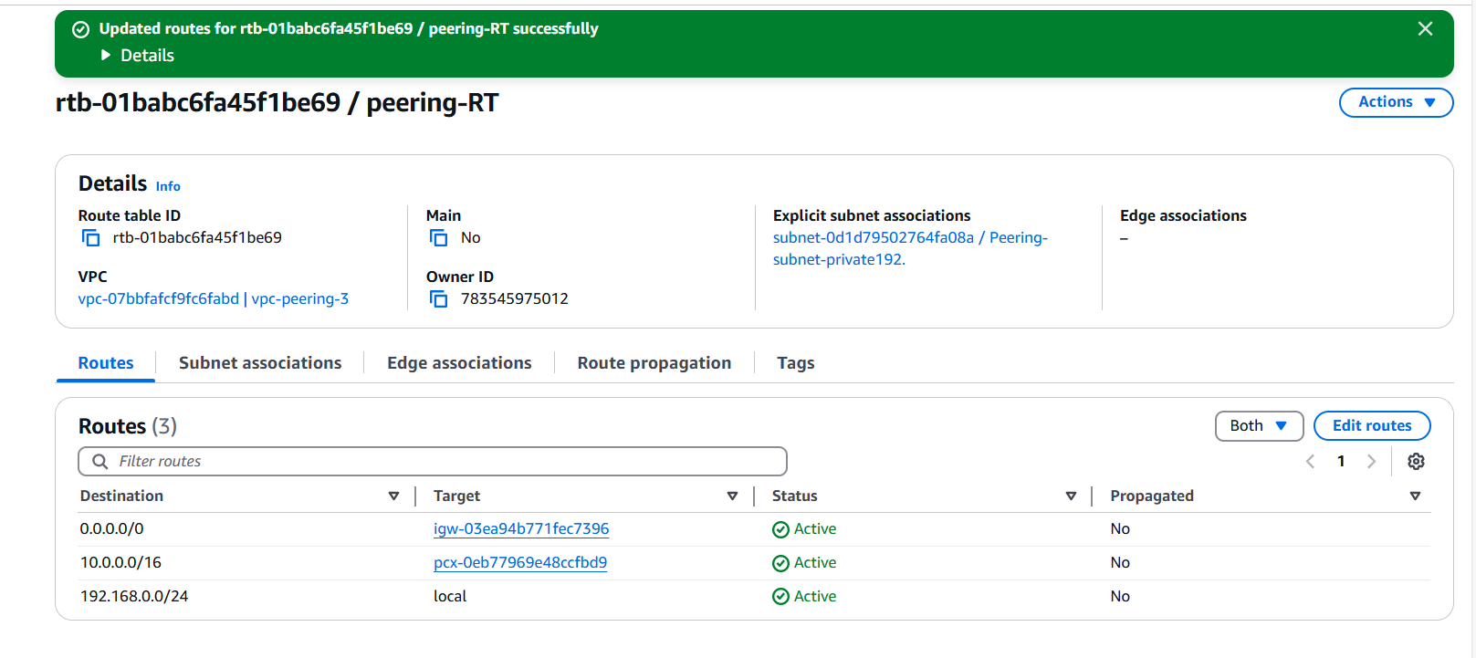

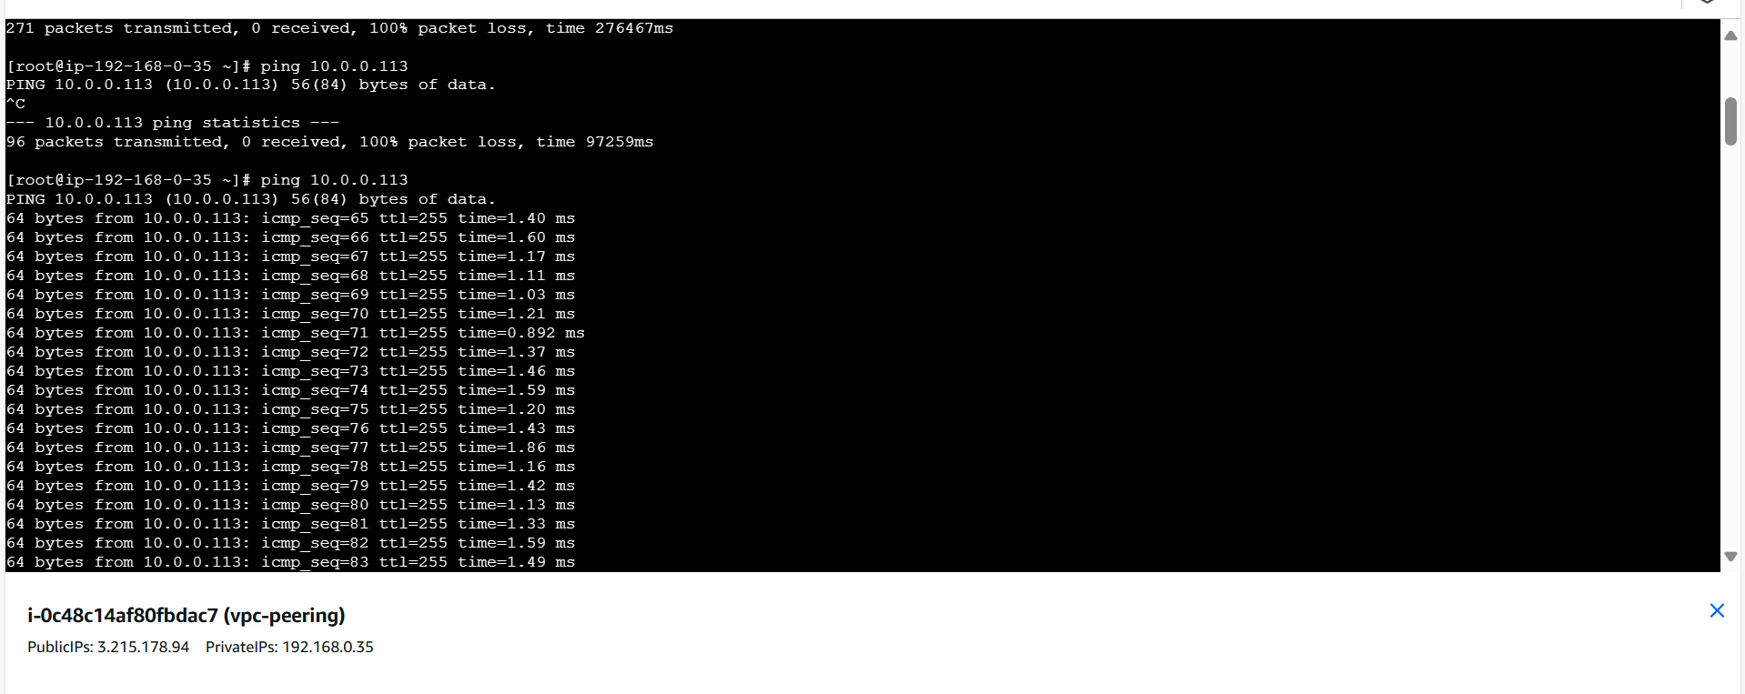

**4) Setup VPC Transits gateway.**

Amazon VPC Transit Gateways is a network transit hub used to interconnect virtual private clouds (VPCs) and on-premises networks. As your cloud infrastructure expands globally, inter-

Region peering connects transit gateways together using the AWS Global Infrastructure.

All network traffic between AWS data centers is automatically encrypted at the physical layer.

Transit gateway concepts The following are the key concepts for transit gateways: • Attachments — You can attach the following: • One or more VPCs • A Connect SD-WAN/third-party network appliance • An AWS Direct Connect gateway • A peering connection with another transit gateway • A VPN connection to a transit gateway • Transit gateway Maximum Transmission Unit (MTU) — The maximum transmission unit (MTU) of a network connection is the size, in bytes, of the largest permissible packet that can be passed over the connection. The larger the MTU of a connection, the more data that can be passed in a single packet. A transit gateway supports an MTU of 8500 bytes for traffic between VPCs, AWS Direct Connect, Transit Gateway Connect, and peering attachments (intra-Region, inter-Region, and Cloud WAN peering attachments). Traffic over VPN connections can have an MTU of 1500 bytes. • Transit gateway route table — A transit gateway has a default route table and can optionally have additional route tables. A route table includes dynamic and static routes that decide the next hop based on the destination IP address of the packet. The target of these routes could be any transit gateway attachment. By default, transit gateway attachments are associated with the default transit gateway route table. • Associations — Each attachment is associated with exactly one route table. Each route table can be associated with zero to many attachments. • Route propagation — A VPC, VPN connection, or Direct Connect gateway can dynamically propagate routes to a transit gateway route table. With a Connect attachment, the routes are Transit gateway concepts 1 Amazon VPC AWS Transit Gateway propagated to a transit gateway route table by default. With a VPC, you must create static routes to send traffic to the transit gateway. With a VPN connection, routes are propagated from the transit gateway to your on-premises router using Border Gateway Protocol (BGP). With a Direct Connect gateway, allowed prefixes are originated to your on-premises router using BGP. With a peering attachment, you must create a static route in the transit gateway route table to point to the peering attachment

Work with transit gateways

You can create, access, and manage your transit gateways using any of the following interfaces:

• AWS Management Console — Provides a web interface that you can use to access your transit gateways.

• AWS Command Line Interface (AWS CLI) — Provides commands for a broad set of AWS services, including Amazon VPC, and is supported on Windows, macOS, and Linux. For more information, see AWS Command Line Interface.

• AWS SDKs — Provides language-specific API operations and takes care of many of the connection details, such as calculating signatures, handling request retries, and handling errors.

• Query API — Provides low-level API actions that you call using HTTPS requests. Using the Query API is the most direct way to access Amazon VPC, but it requires that your application handle low-level details such as generating the hash to sign the request, and handling errors.

How Amazon VPC Transit Gateways work

In AWS Transit Gateway a transit gateway acts as a Regional virtual router for traffic flowing between your virtual private clouds (VPCs) and on-premises networks. A transit gateway scales elastically based on the volume of network traffic. Routing through a transit gateway operates at layer 3, where the packets are sent to a specific next-hop attachment, based on their destination IP addresses

Example architecture diagram The following diagram shows a transit gateway with three VPC attachments. The route table for each of these VPCs includes the local route and routes that send traffic destined for the other two VPCs to the transit gateway.

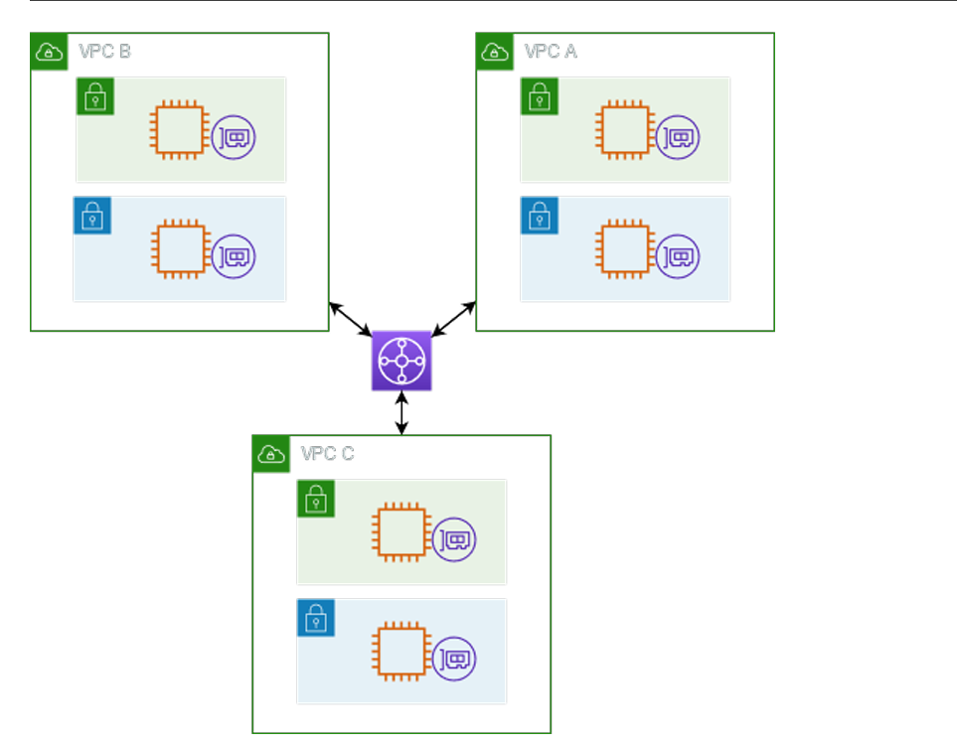

Steps To set up VPC Transit Gateway

First Create 3 VPC's using create VPC in amazon console

Create VPC-1 with CIDR 12.0.0.0/16

Create Internet Gateway and attach with vpc-1

Create Subnets - Public-subnet-vpc1 and subnet CIDR 12.0.0.0/24

Create Route Table Pub-RT-vpc1

Edit Subnet associations with Public Subnet

Edit routes using 0.0.0.0/0 in Destination and in Target attach internet Gateway created vpc-1

Now Launch Ec-2 TGW-vpc1

Generate new key pair tgw-vpc1.pem

In Network settings select VPC-1 and Subnet as Public-subnet-vpc1

Auto-assign public ip Enable

Now select Launch instance

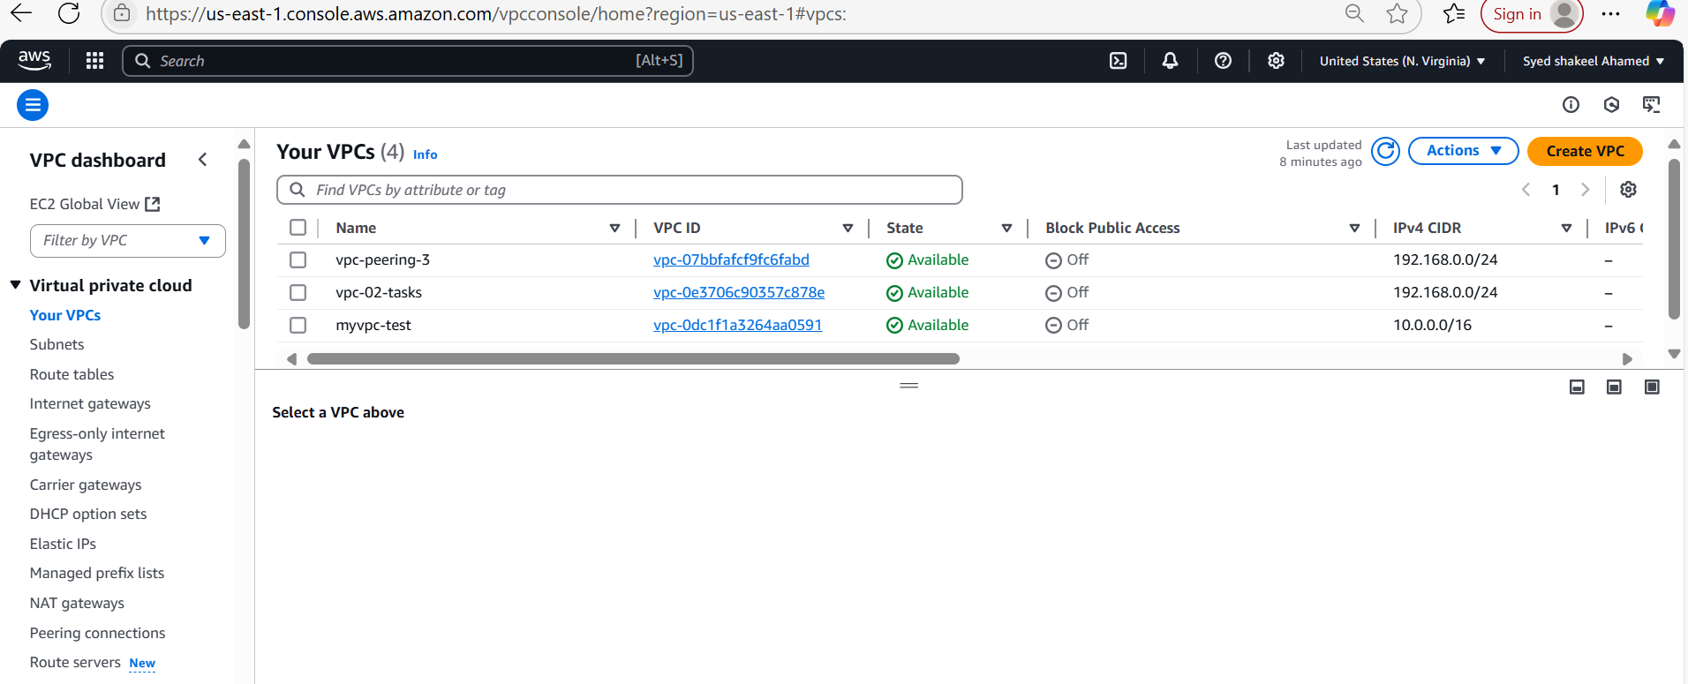

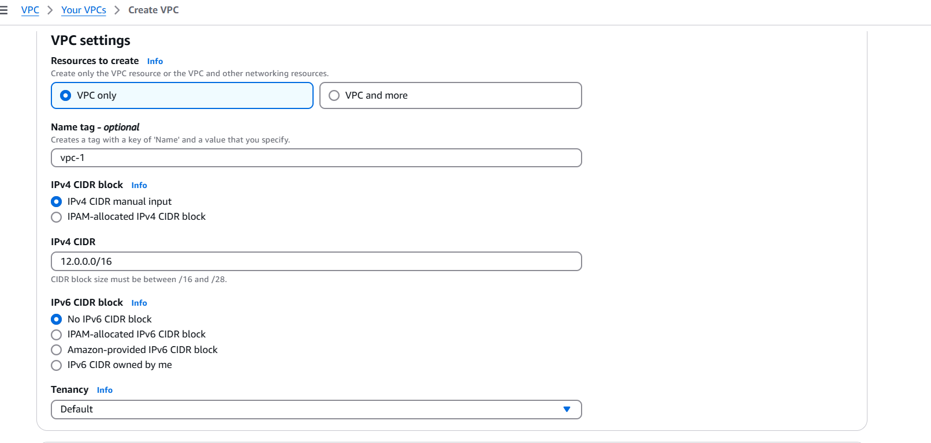

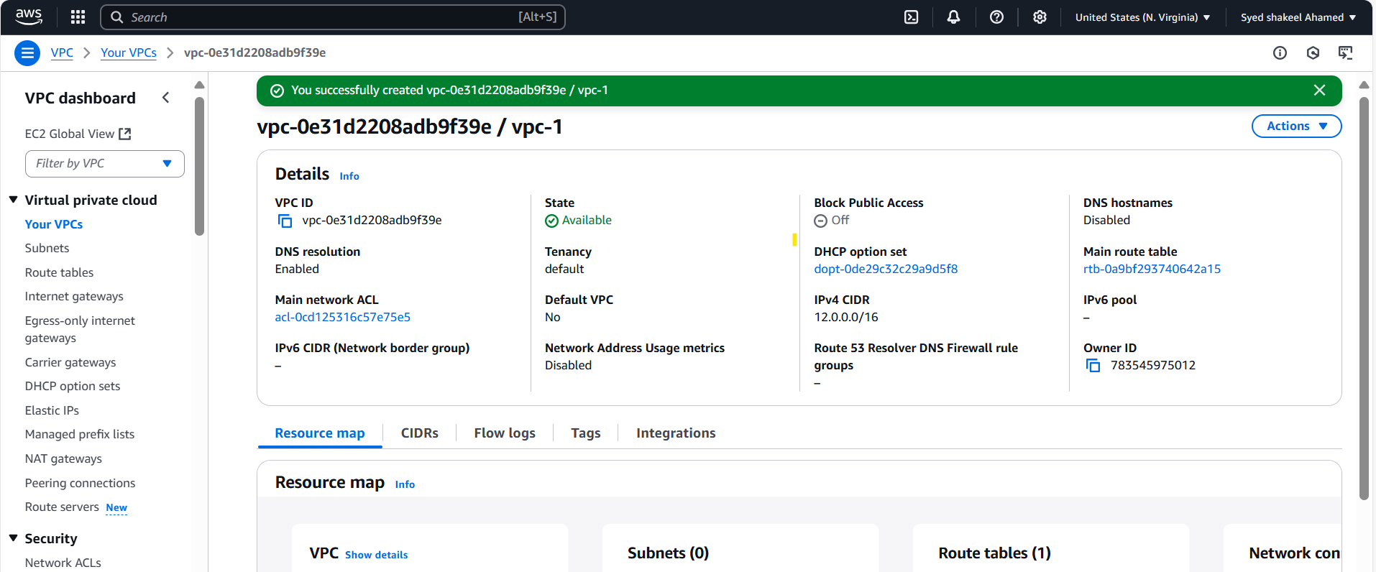

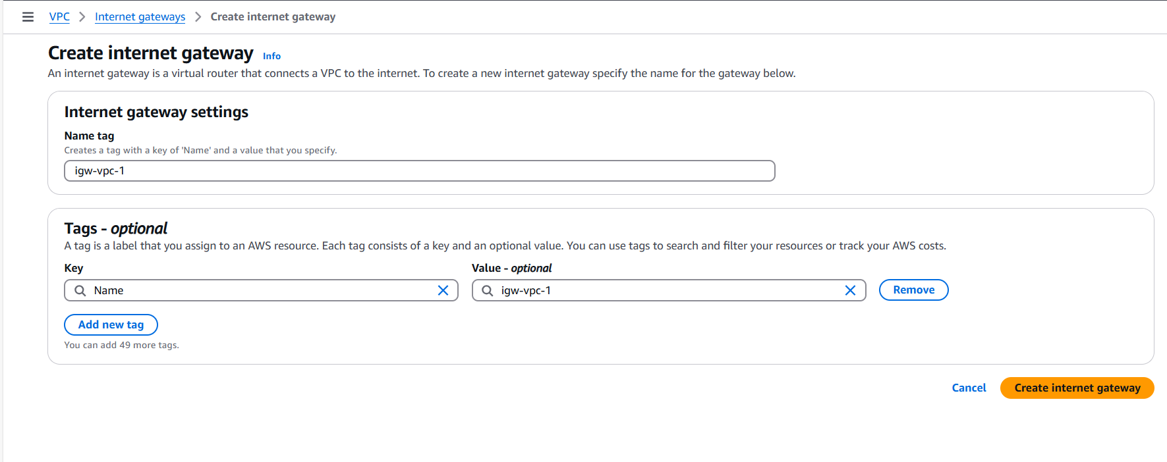

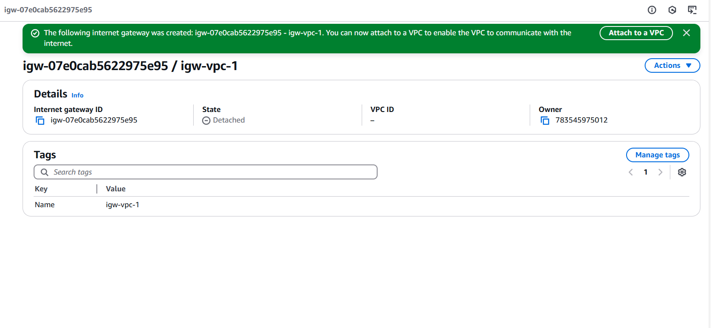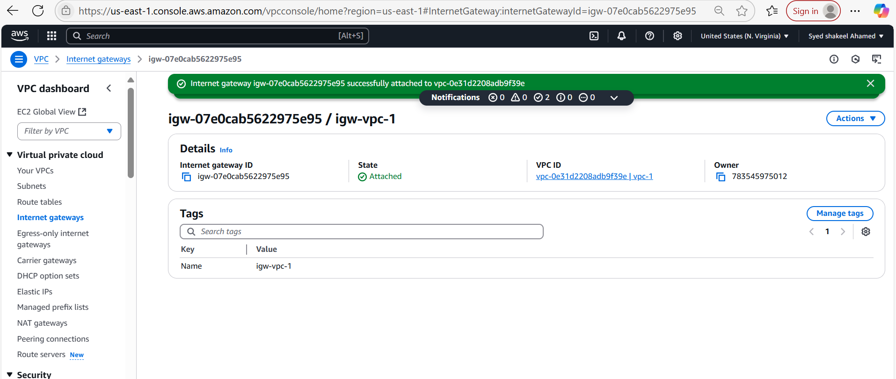

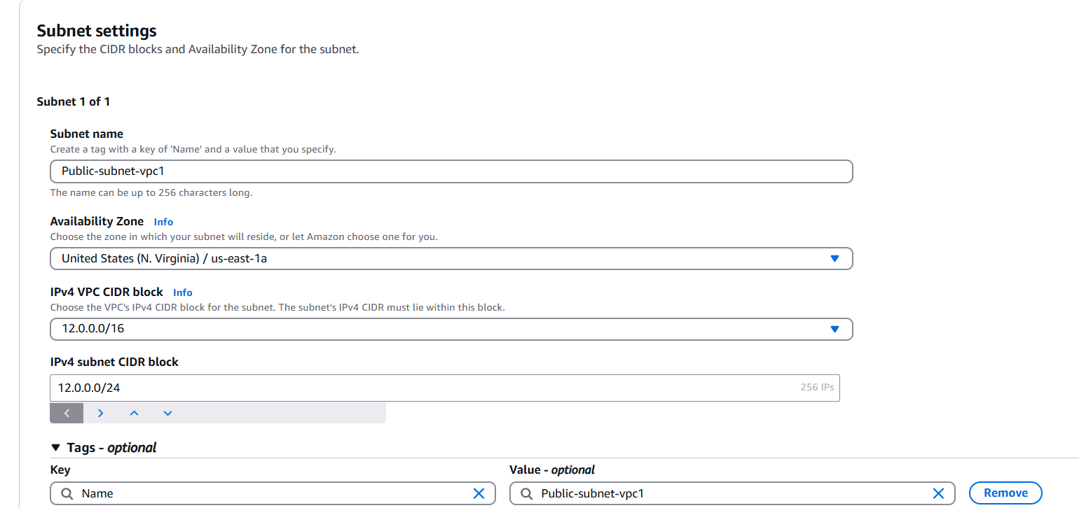

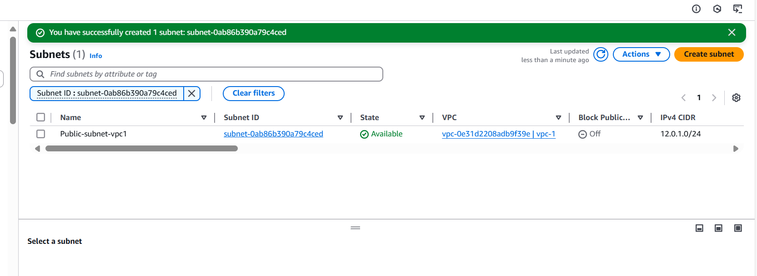

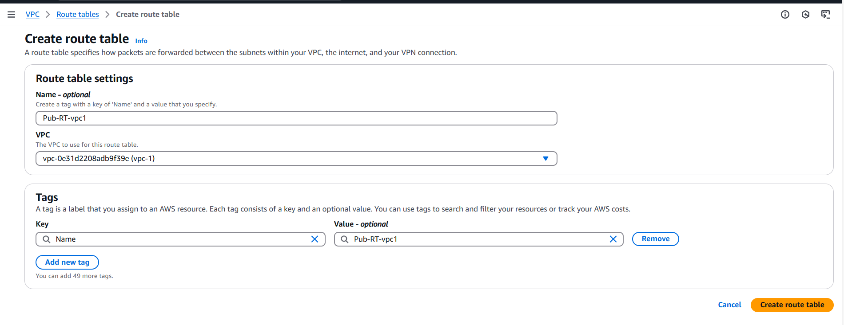

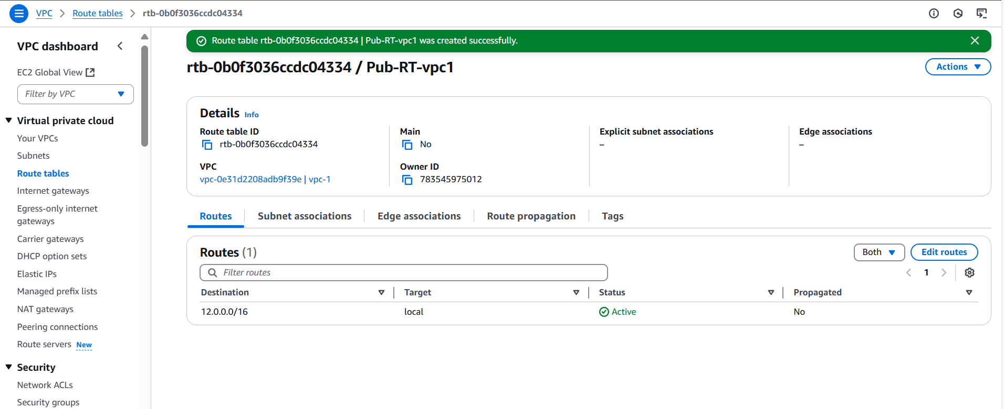

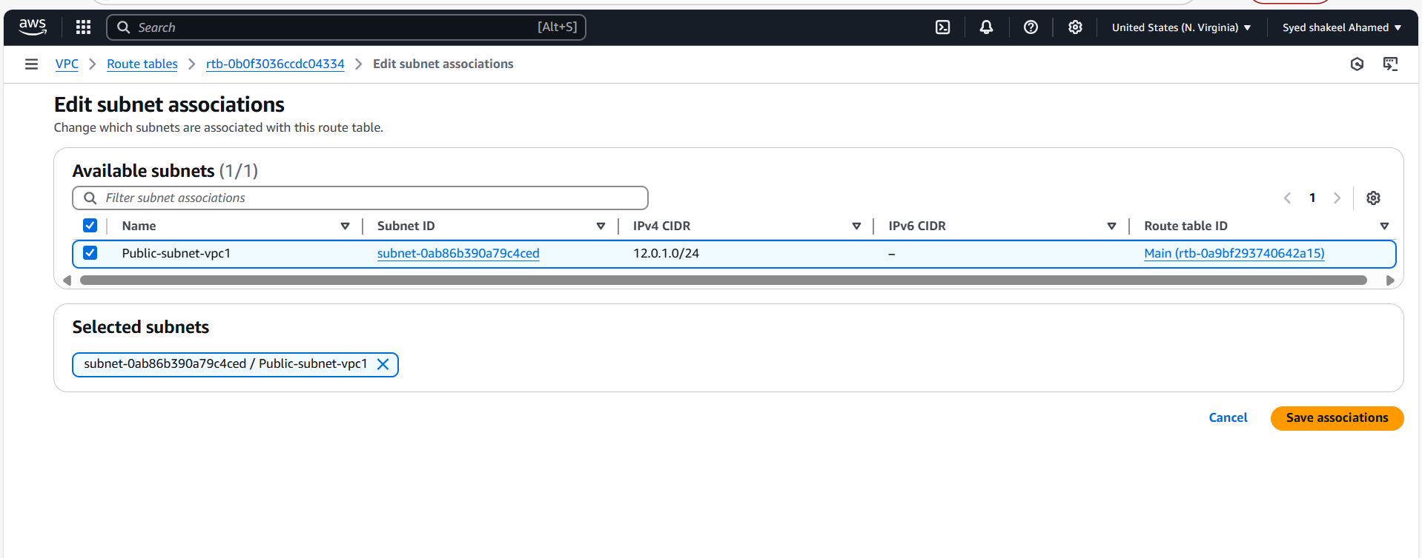

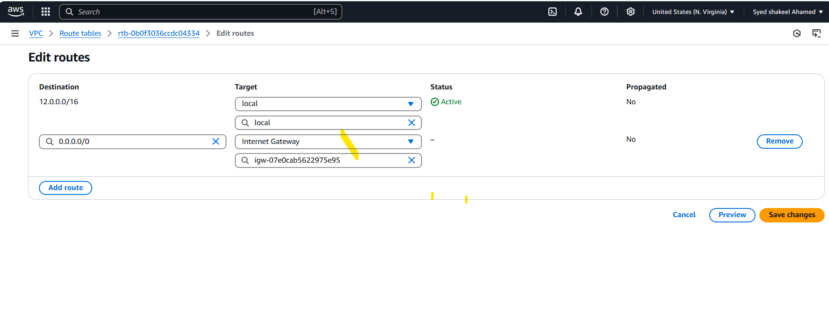

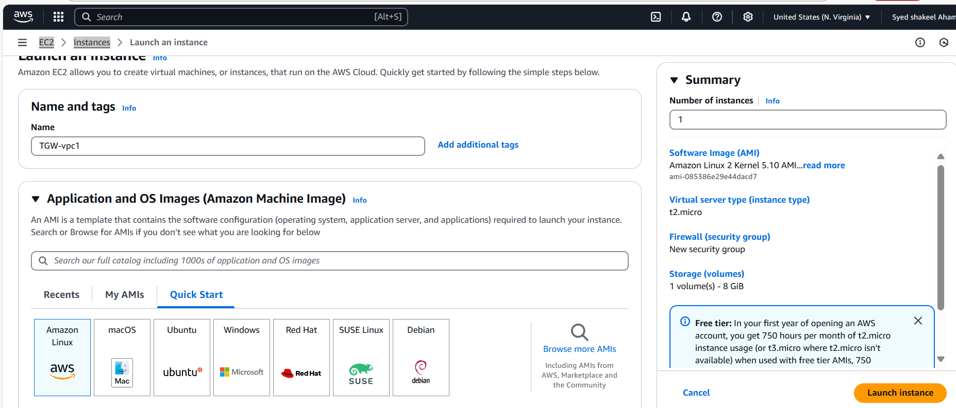

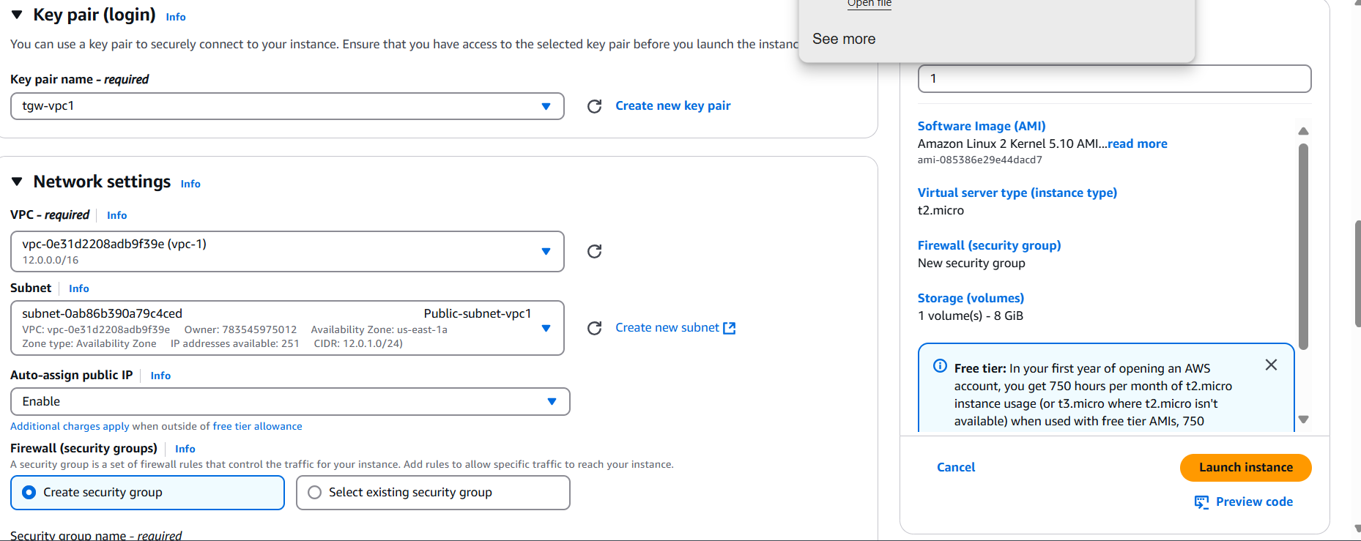

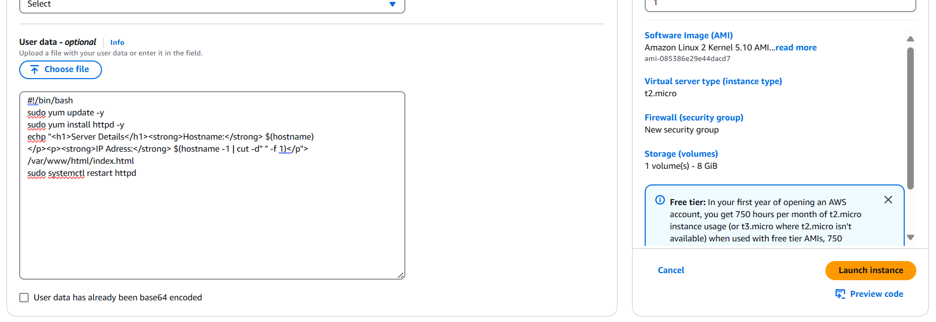

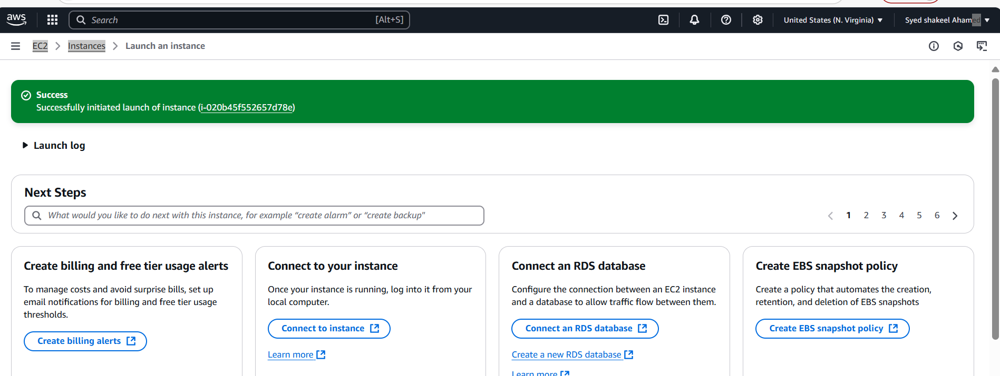

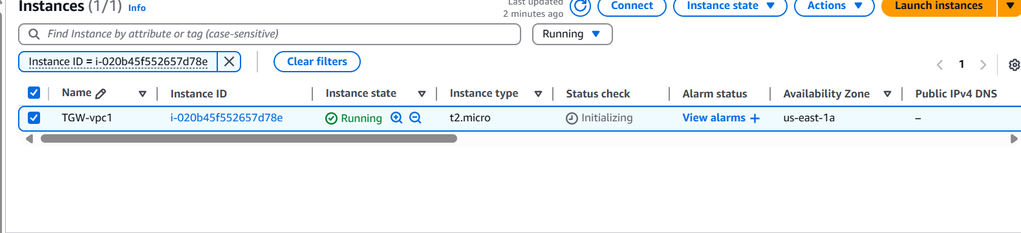

VPC-2-Set up

Create VPC-2 with CIDR 13.0.0.0/16

Create Internet Gateway and attach with vpc-2

Create Subnets - Public-subnet-vpc1 and subnet CIDR 13.0.0.0/24

Create Route Table Pub-RT-vpc2

Edit Subnet associations with Public Subnet

Edit routes using 0.0.0.0/0 in Destination and in Target attach internet Gateway created vpc-2

Now Launch Ec-2 TGW-vpc2

Generate new key pair tgw-vpc2.pem

In Network settings select VPC-2 and Subnet as Public-subnet-vpc2

Auto-assign public ip Enable

Now select Launch instance

VPC-3 setup

Create VPC-3 with CIDR 14.0.0.0/16

Create Internet Gateway and attach with vpc-3

Create Subnets - Public-subnet-vpc1 and subnet CIDR 14.0.0.0/24

Create Route Table Pub-RT-vpc3

Edit Subnet associations with Public Subnet

Edit routes using 0.0.0.0/0 in Destination and in Target attach internet Gateway created vpc-3

Now Launch Ec-2 TGW-vpc3

Generate new key pair tgw-vpc3.pem

In Network settings select VPC-3 and Subnet as Public-subnet-vpc3

Auto-assign public ip Enable

Now select Launch instance

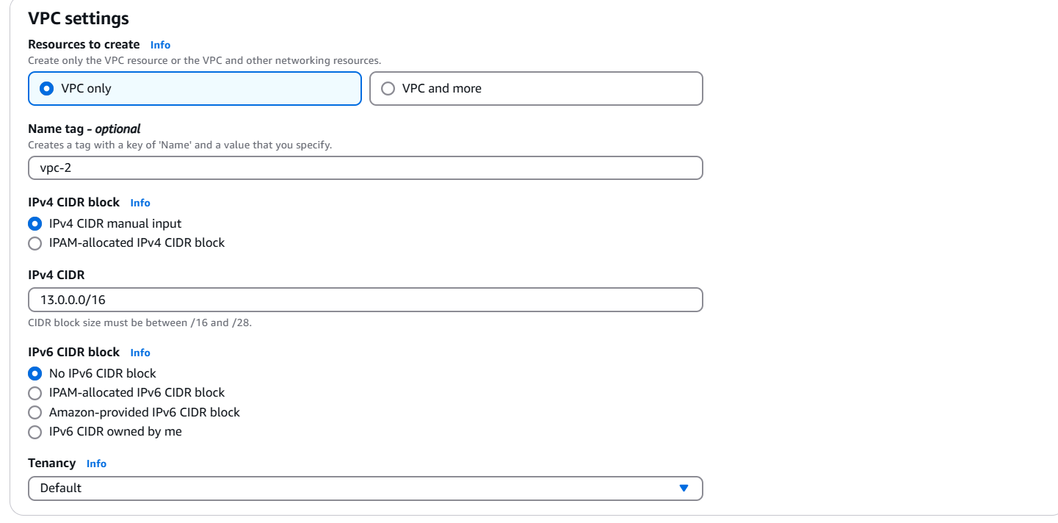

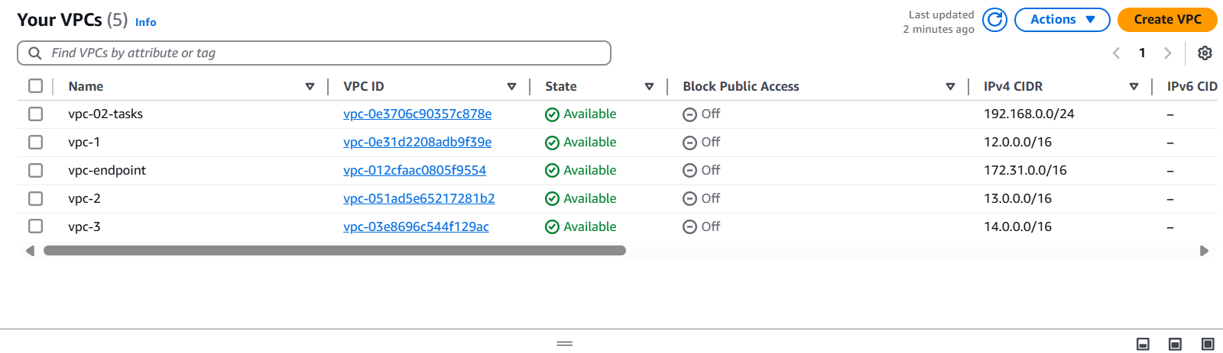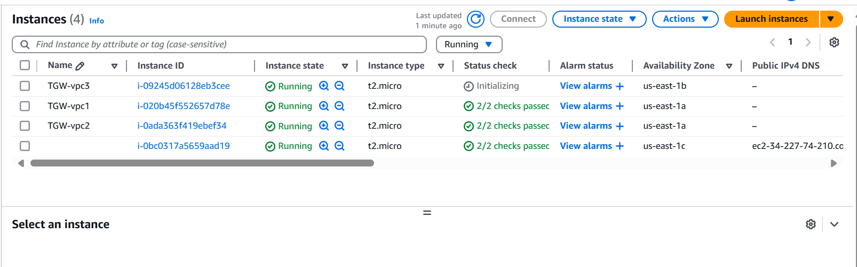

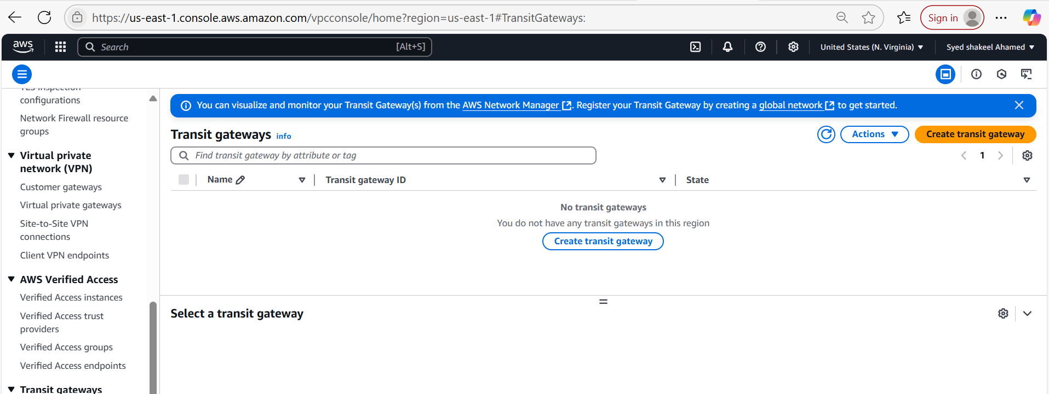

Create Transit Gateway

Go to Amazon Console and in left panel select Transit Gateway

select create Transit Gateway TGW-vpc and Description you can mention as set up transit gateway vpc-1-2-3

Configurate the Transit Gateway

Mention ASN(Amazon side Autonomous System Number) default number 64512 and click on create Transit Gateway

Now select Transit Gateway Attachments

Create Transit Gateway Attachments:

Attach individual VPC's and create 3 attachments by selecting appropriate vpc's

Now Come to Route Table

In Public-RT-vpc1 Edit routes for vpc2 and vpc3 and save the changes

In Public-RT-vpc2 Edit Routes for vpc1 and vpc3 and save the changes

In Public-RT-vpc3 Edit Routes for vpc1 and vpc3 and save the changes

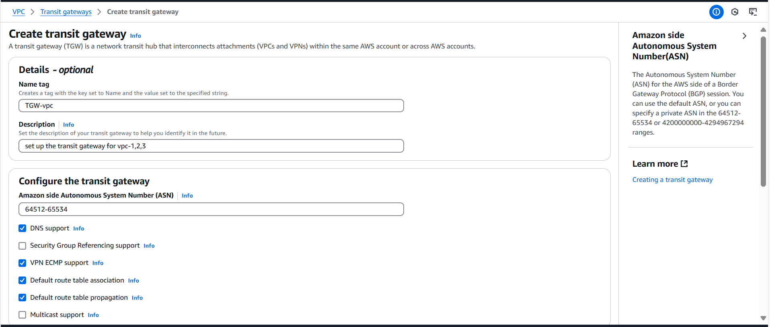

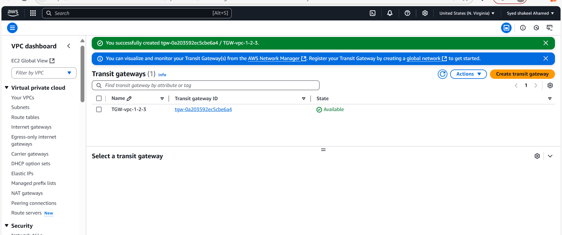

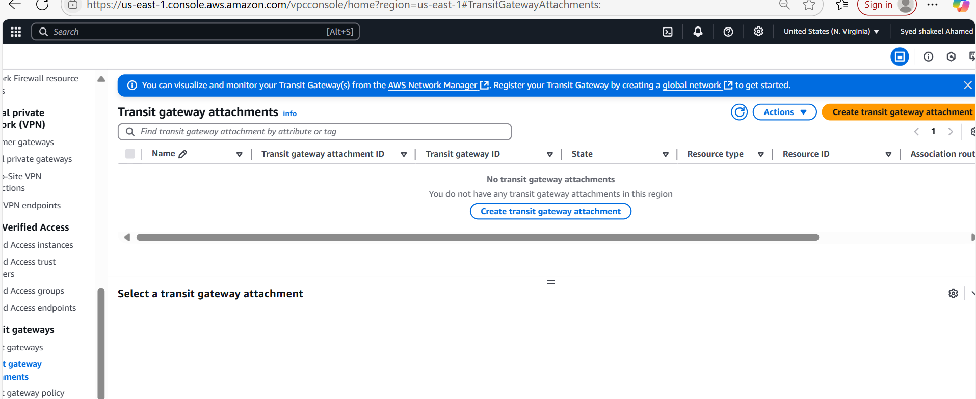

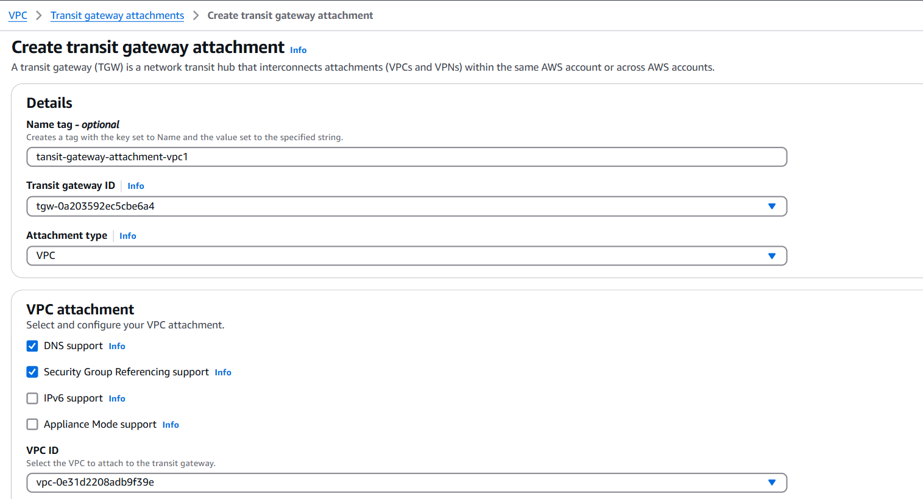

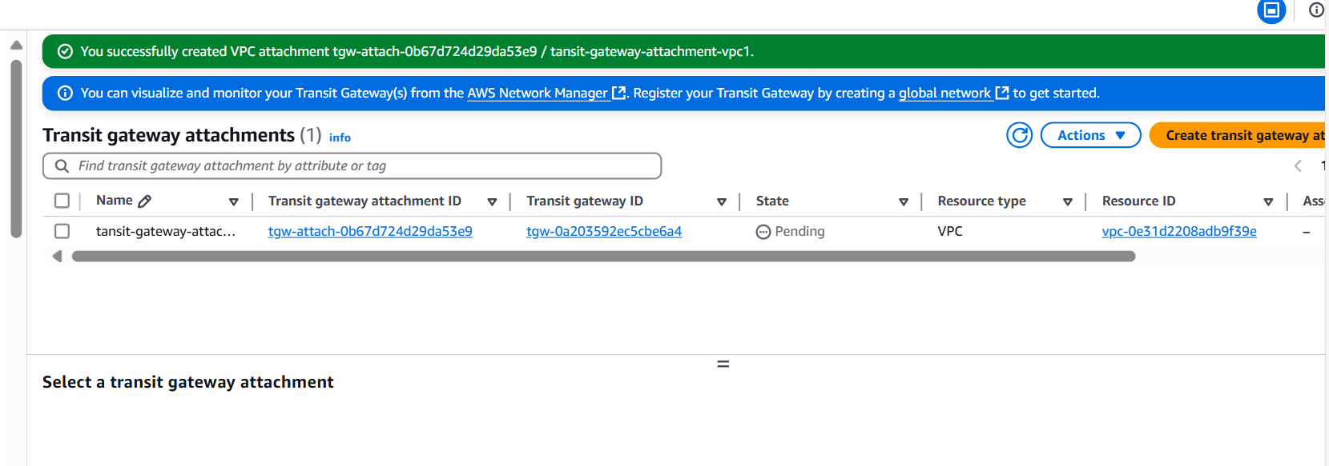

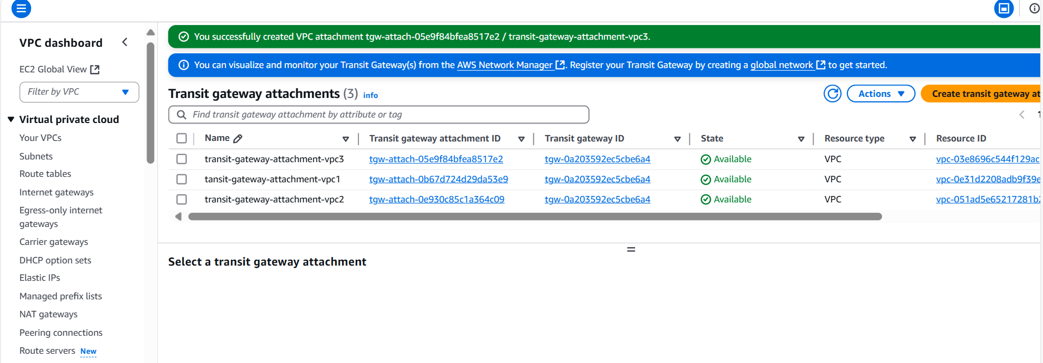

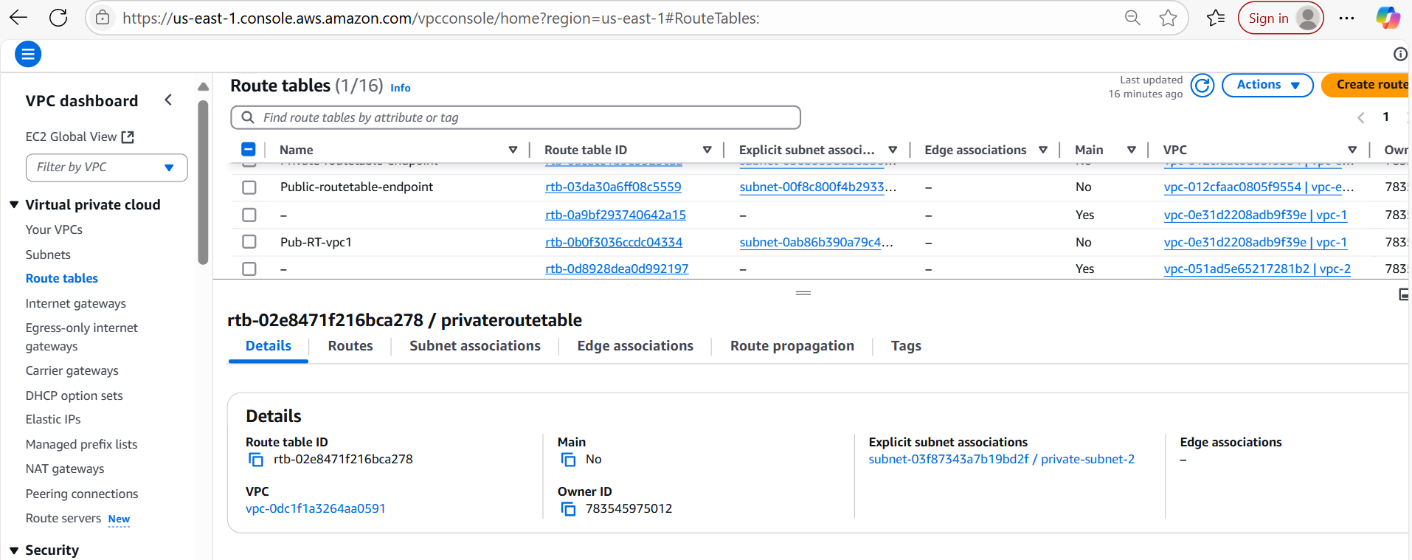

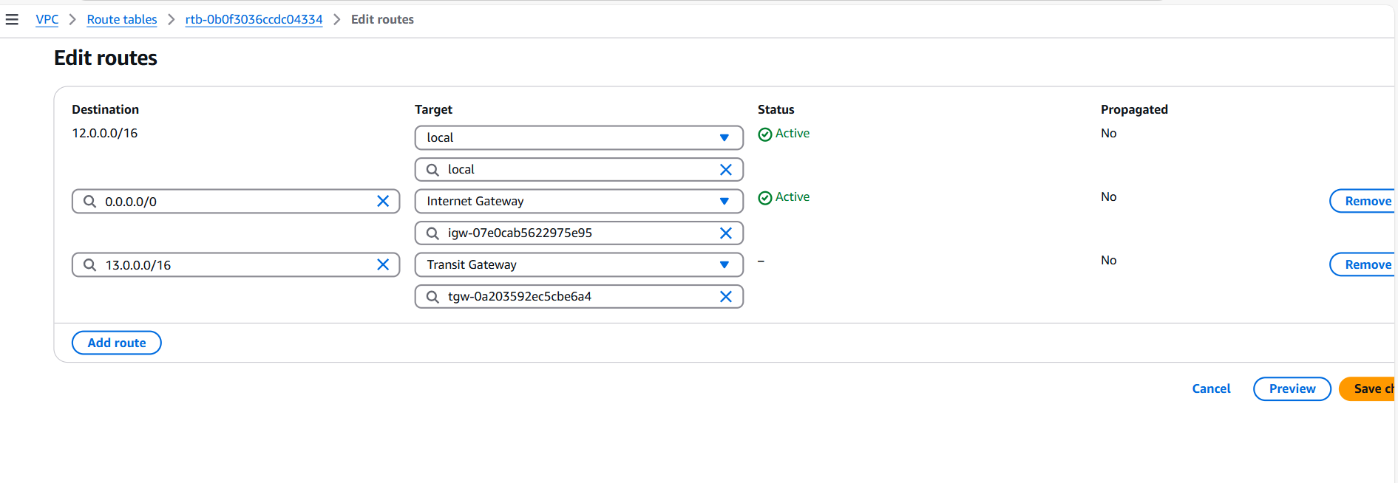

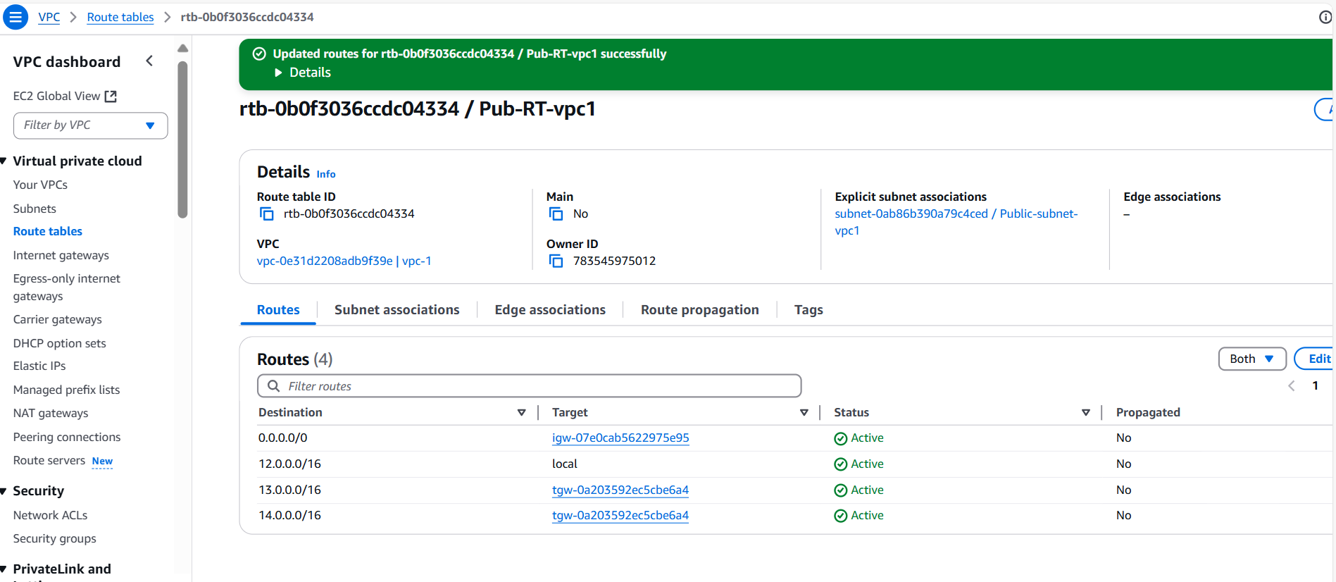

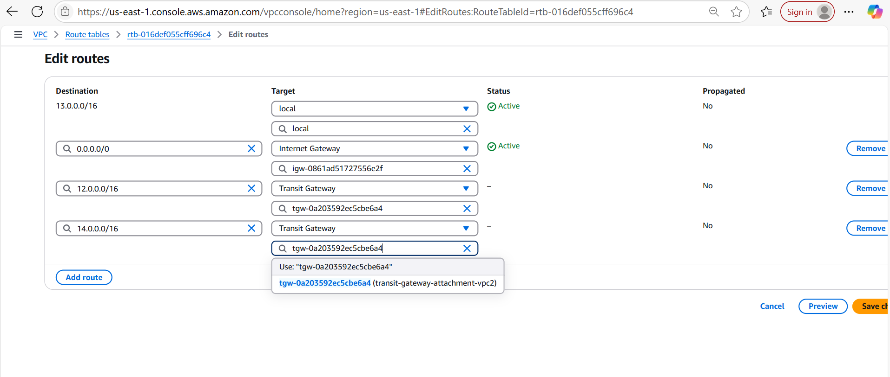

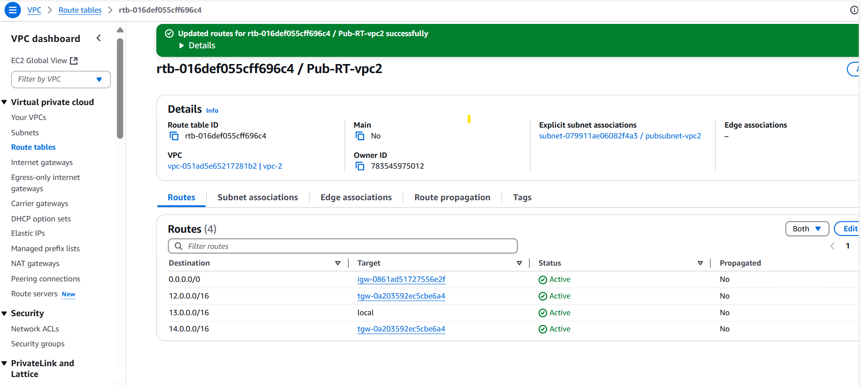

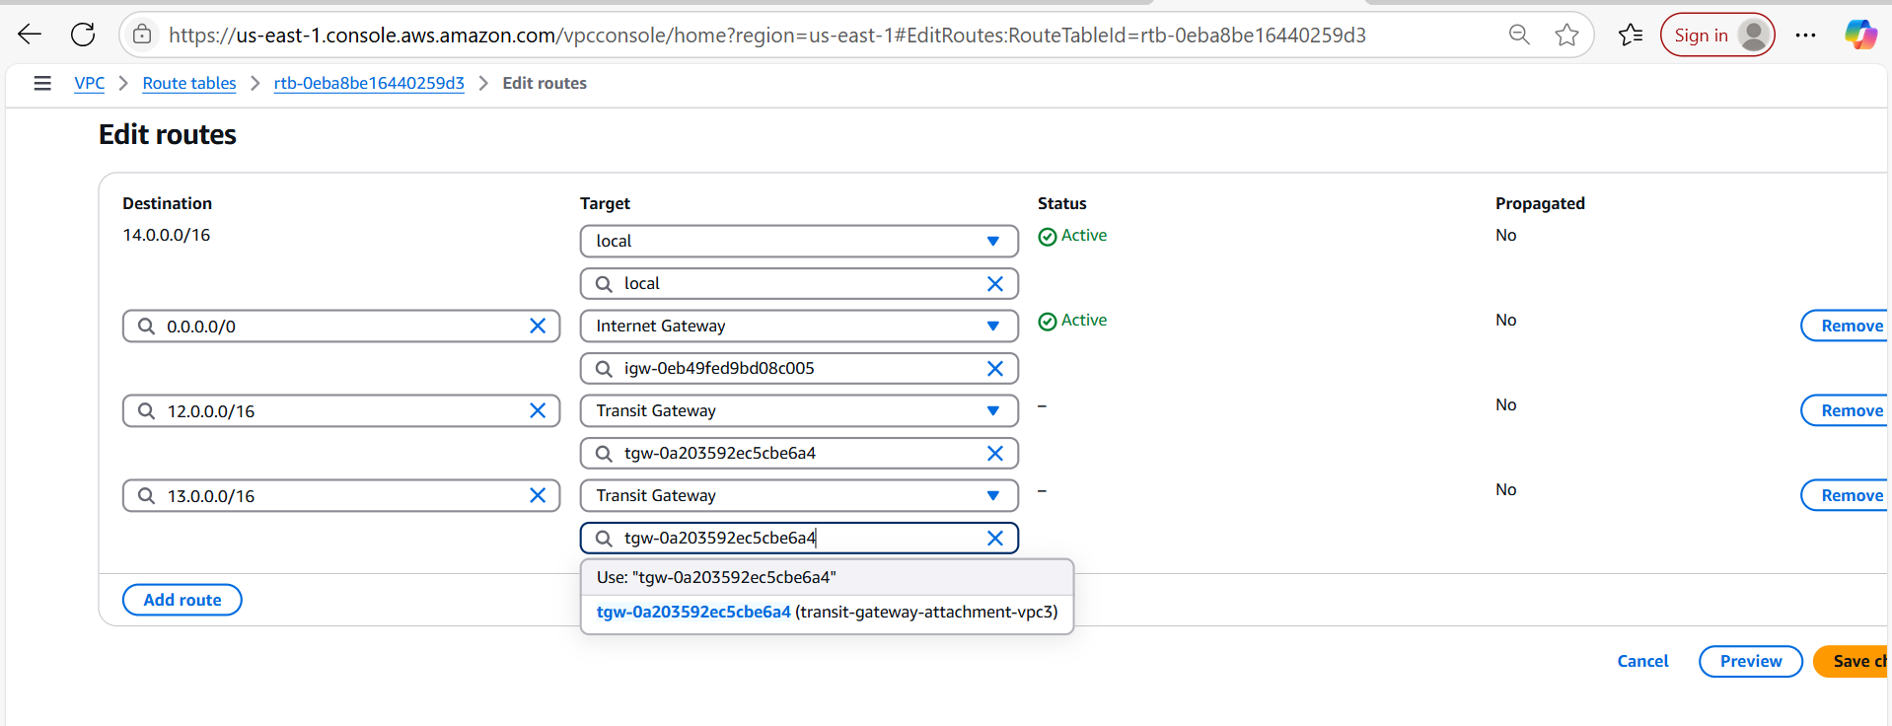

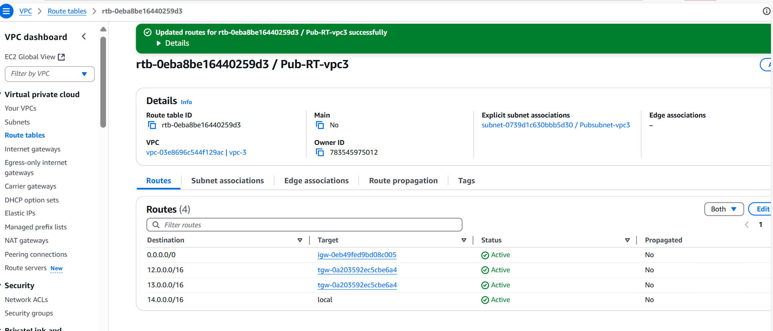

Testing :

TGW-vpc-1

Installed httpd and checked using Public ip of ec-2 httpd is running

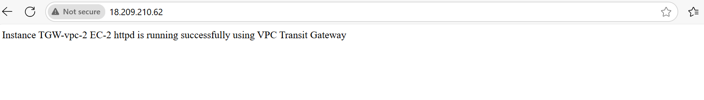And also checked for both vpc-2 and vpc-3 using private ip’s of both instances

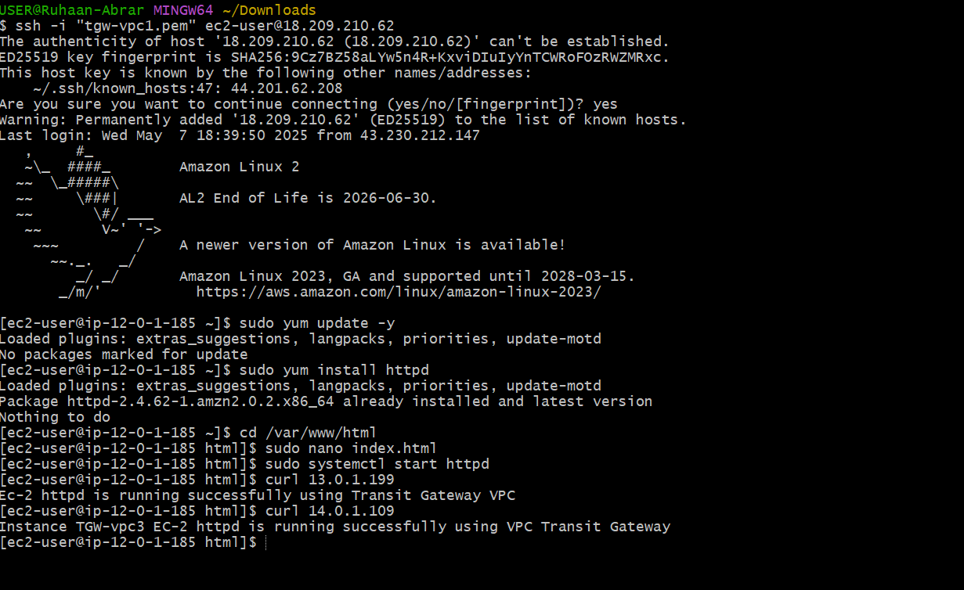

TGW-vpc-2

Installed httpd service and it is running

Checked with Public ip of this server

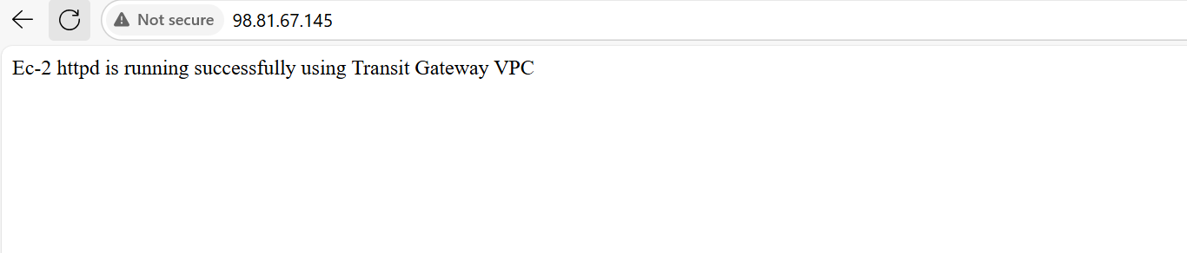

Also with the Private ip’s of both VPC-1 and VPC-3

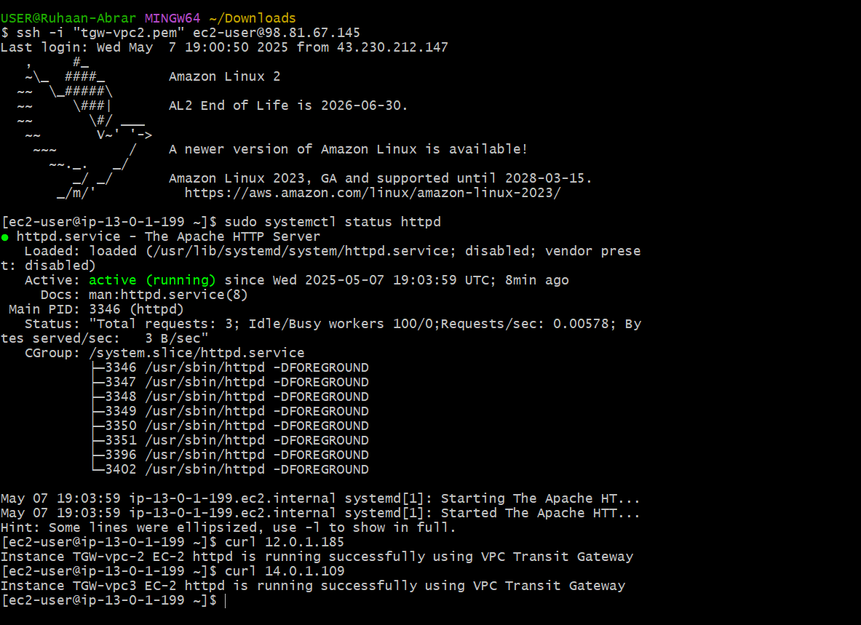

TGW-vpc-3

Installed httpd service and it is running

Checked with Public Ip of this instance

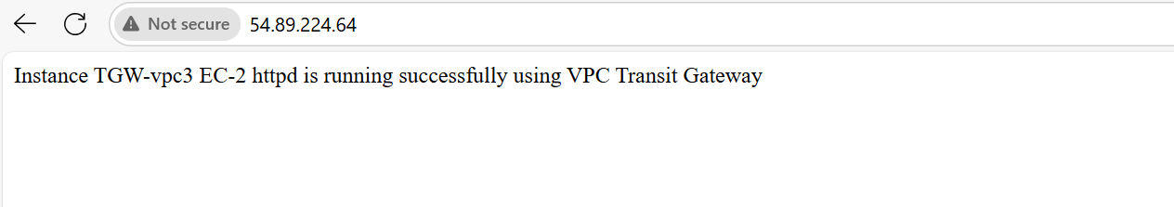

Also checked with Private IP’s of VPC-1 and VPC-2

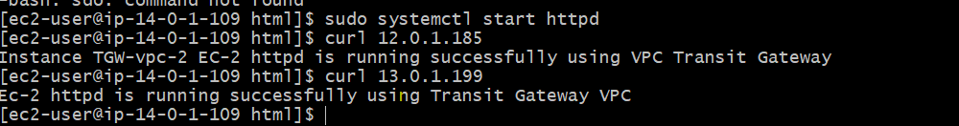

Hence VPC -Transit Gateway set up and configured Successfully.

**5) Setup VPC End Point**

In modern cloud architectures, ensuring secure and efficient communication between services is critical. One of the most effective ways to do this within AWS is by using VPC (Virtual Private Cloud) Endpoint services.

VPC endpoint’s role in connecting resources securely without requiring access over the public internet.

* **Interface Endpoints (PrivateLink)**: Direct connection to services like AWS Lambda, EC2, etc.
* **Gateway Endpoints**: For services like S3 or DynamoDB.

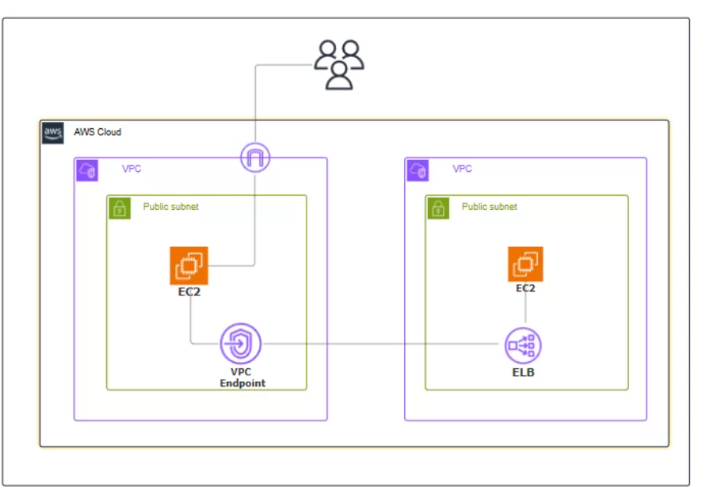

Navigate the VPC and Click on create VPC.

Required VPC-1 and 1-Public subnet and 1-Private subnet

Use default VPC which is already available in Amazon Console

Now come to subnets section

Create Public subnet with CIDR 172.31.0.0/16 and subnet CIDR 172.31.96.0/20

Create Private subnet with CIDR 172.31.0.0/16 and subnet CIDR 172.31.128.0/20

Now create EC2 instances 1 using Public subnet with auto assign ip enable with proper networking configurations

Now create EC2 instance using Private subnet without auto-assign ip enable with proper networking configurations.

Create s3 bucket or else if already exists use that

Now connect to CLI (GitBash) using Public IP of EC2 using SSH

Now check for aws –version check for aws CLI installed or not

If it installed do the AWS configuration using aws configure

Enter the details as AWS access key id , AWS secret key id ,default region and default output format(json)

Once the configuration is completed check for aws s3 ls

As we connected to Public Ec2 we will be able to see the details

Now check the AWS configuration with Private EC2

Try connecting with ssh –i .pem ec2-user@private ip; Its not possible to connect

So use Bastian/jump server to connect

Now copy and generate the Key pair using existed keypair by creating new file and change the file modification chmod 400 file.pem

Now try to connect using ssh –i file.pem ec2-user@private ip

We will be successfully connected however no details will be reflected because of no internet access.

So to avoid this we will create and set up VPC Endpoint and try to connect to private EC2

**Test the End-to-End Connecti**

Checked the end-to-end connection for aws s3 ls in aws cli and got the output means VPC Endpoint configured successfully.

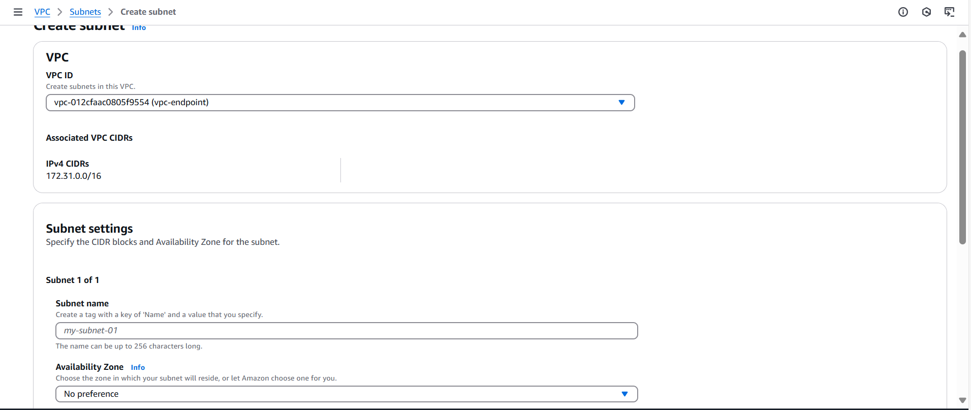

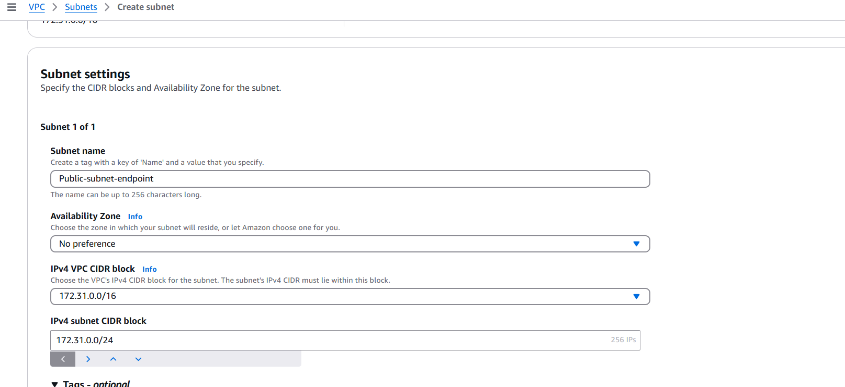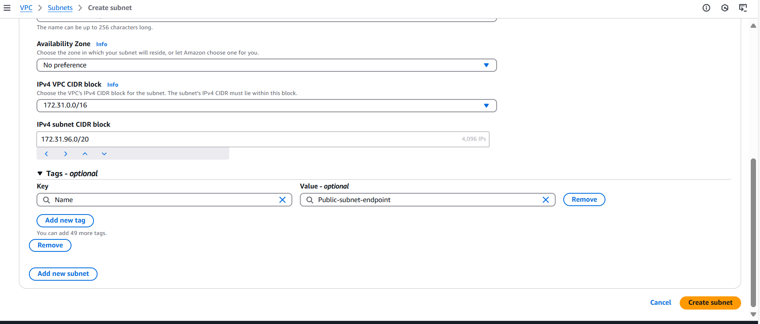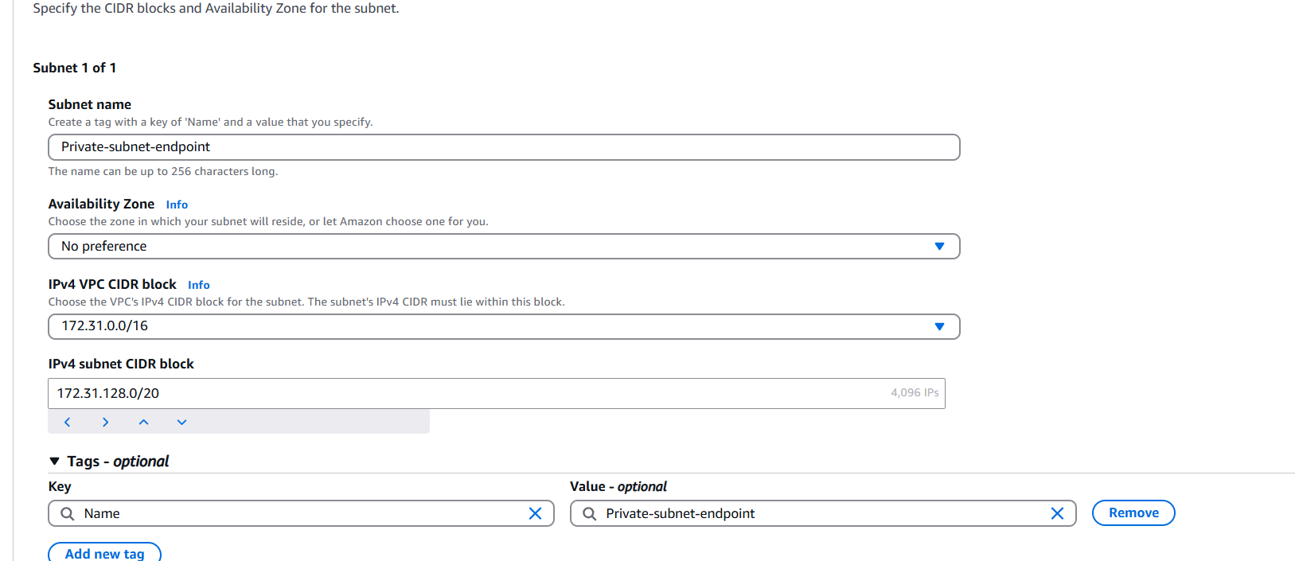

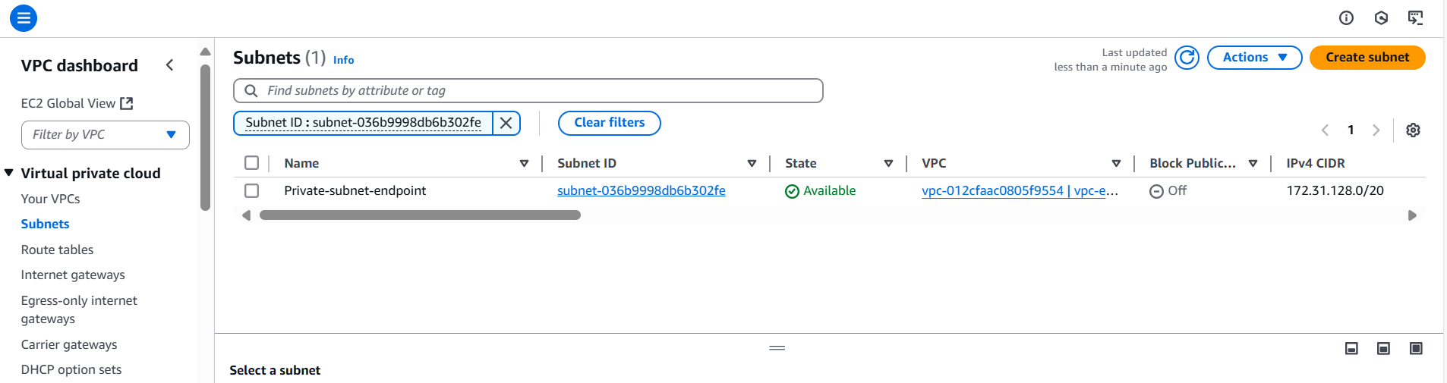

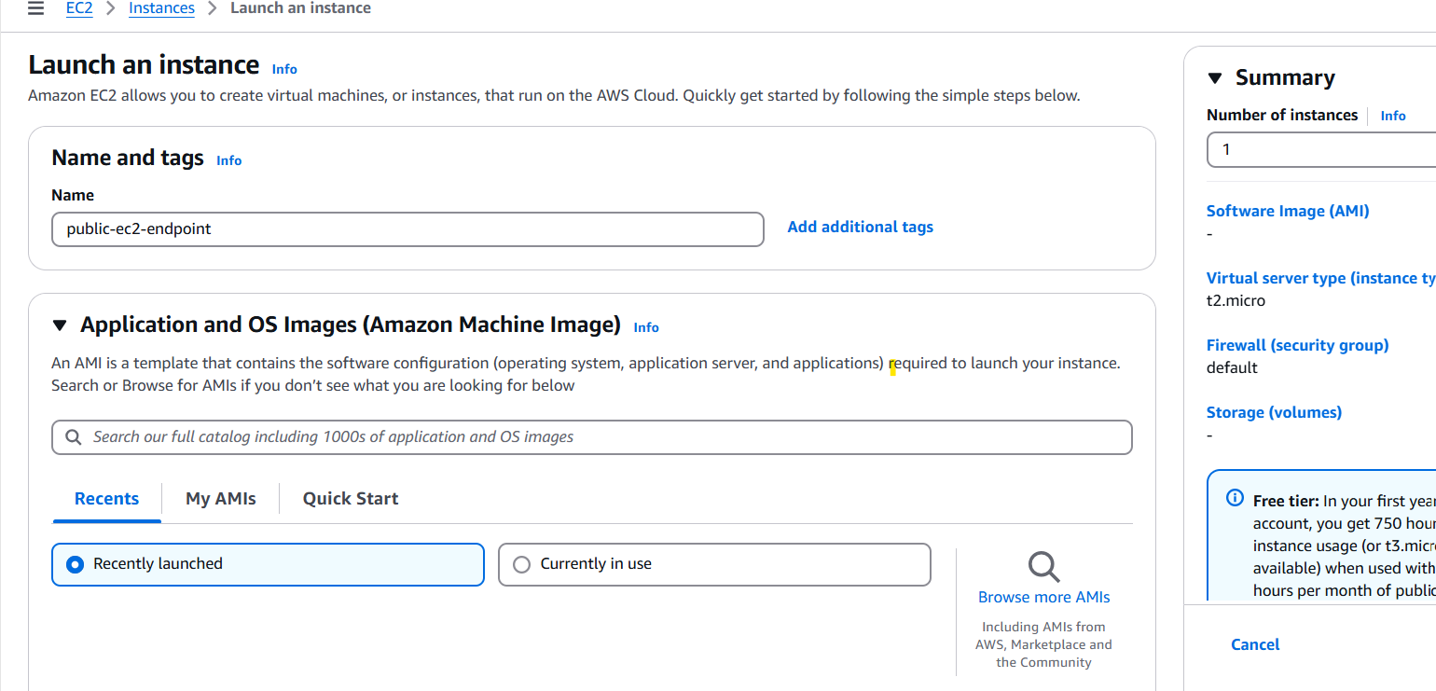

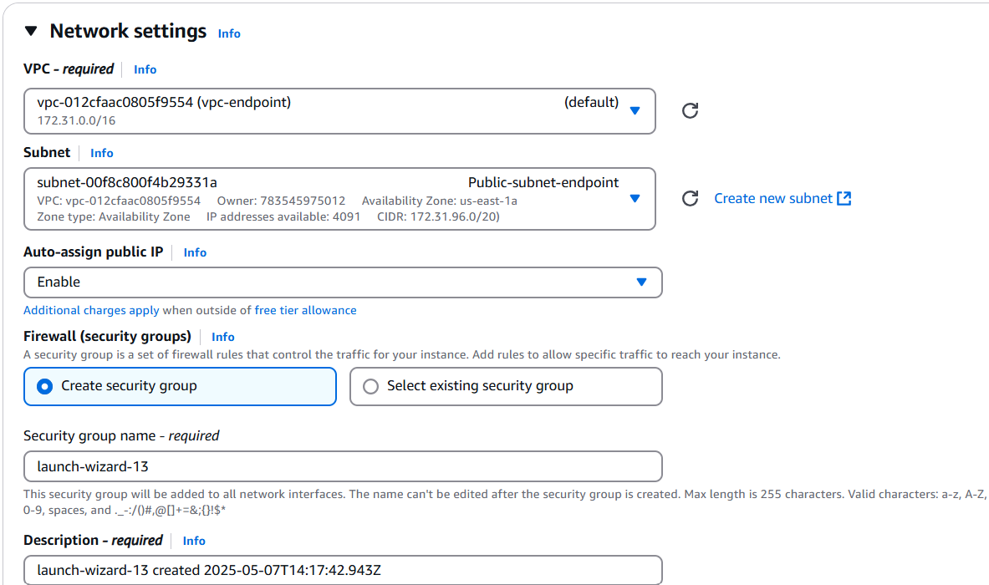

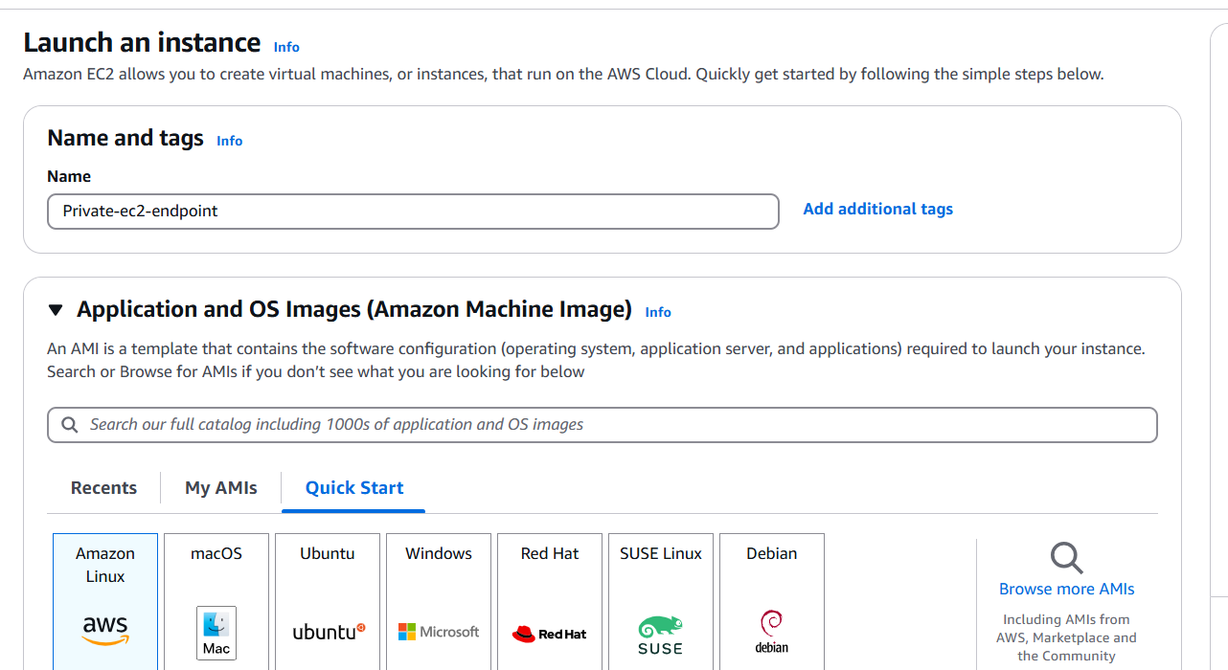

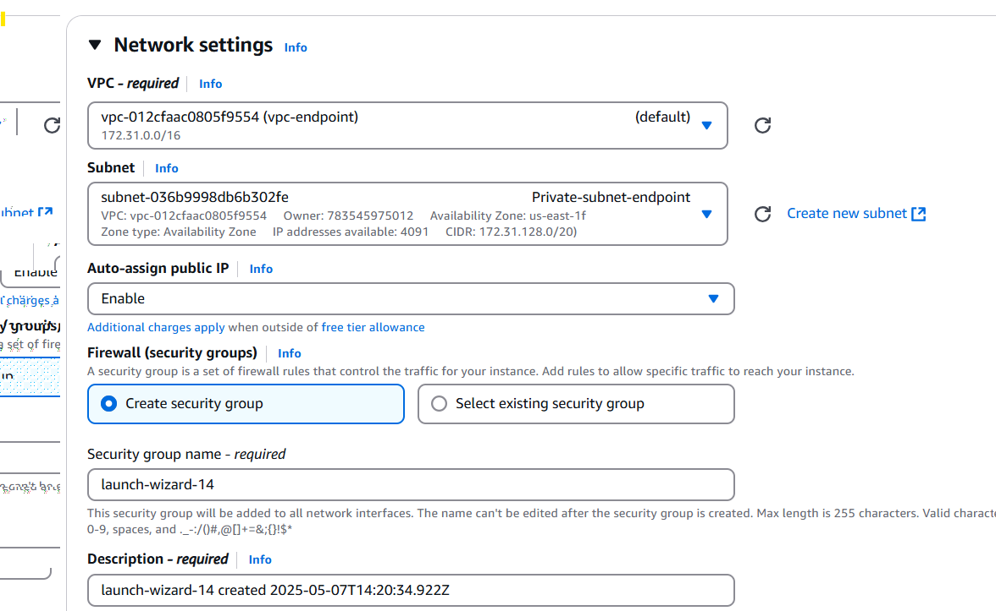

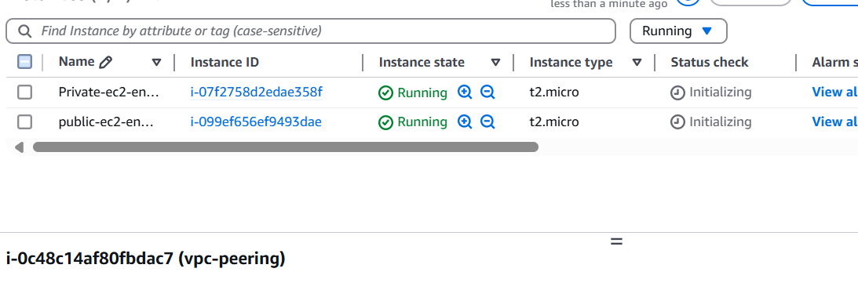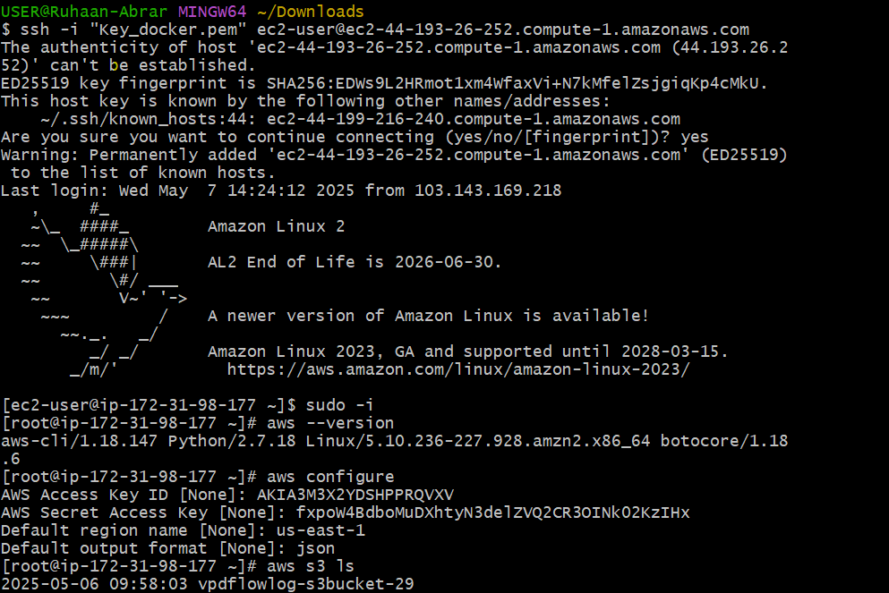

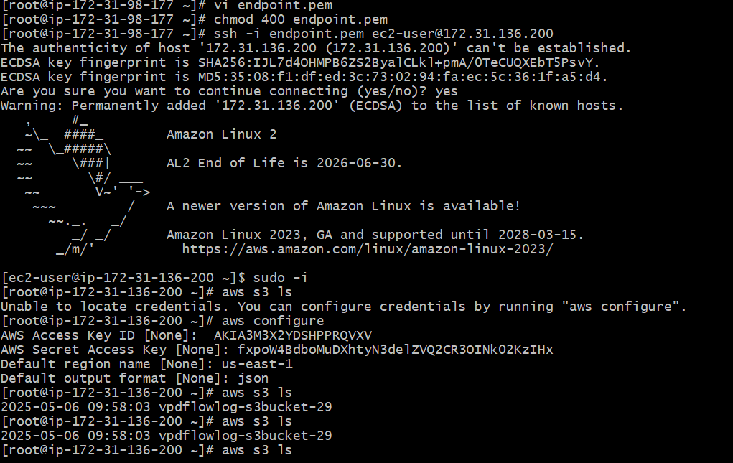

Go to RouteTable and check in subnet associations add Private RouteTable

Now go to Endpoints option and select Create Endpoints

Mention the name as options

Type select AWS Services

Services search for s3 and select the appropriate service for s3 with correct region

After this we will get 2 options Gateway and interface

Select Gateway service option

Now come to Network settings select VPC created for Endpoint

and check for Route table-Private Route Table

Policy -VPC endpoint policy controls access to the service and selct Full access for testing purpose

Click on Create Endpoint

Once the Endpoint is successfully created

Test the AWS CLI for aws s3 ls with private ec2 connection ssh in CLI

Now you can see the details of aws s3 ls

Here we didn't create any NAT Gateway to give access of internet for private ec2 instance

SO here we successfully get the details with VPC Endpoint.

